Session One
a. 11 km
b. 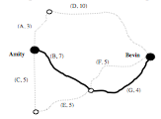
c. There are exactly two odd nodes and the race begins at one of these.
d. A combination of at least two roads chosen from S, N or P to indicate the
intersection.
e. Road J must be avoided – otherwise there is no way, under the rules, of returning to
the left side of Bevin to complete roads B, E, F and G.
f. Road S.
g. 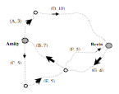
h. 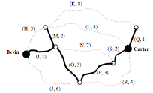
i. 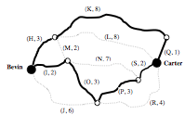i.e. H – K – Q – S – P – O – I
j. 22 km.

Session Two
a. 5
b. 30 km The correct path was B – C – D – C – W. There was no restriction about
passing through C twice.
c. Hamiltonian Path
d. 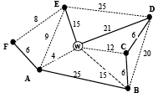
e. Not all vertices are of even degree.
f. Vertex C.
g. D, F, G and 50
h. 125 minutes
i. Activity F is NOT on the critical path
j. 32 minutes. You could accept “Activity F can be increased by 12 minutes”.
k. 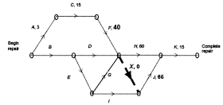 OR 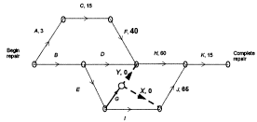
Line MUST have arrow and zero duration.
l. 58 minutes (below left) or 63 minutes (below right)
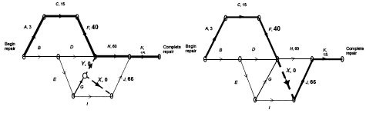
m. 133 minutes (or 138 minutes for the alternative solution)
n. Activity D.

Session Three
a. 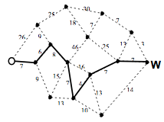
b. 46 km
c. Hamiltonian circuit
d. 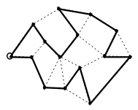
e. A→1, D→4, F→10, K→12
D→4 was found by subtracting time for B from the EST of H. A has a float time of
one hour. The value F→10 comes from a float time found by subtracting the sum of
the times for F and I from the sum of the times for E, G and J. The value K→12 comes from subtracting the starting time for K from the quoted least time required for the project (30 hours).
f. B – C – E – G – J – K
g. 15 hours
h. B and F
i. 3 hours
j. $200

