SESSION ONE
The map below shows the roads that connect the towns of Amity, Bevin and Carter. The towns and the major intersections (indicated by open circles) form the nodes of this network of roads. Labels on roads indicate their names and lengths in kilometres. For instance, (E, 5) indicates Road E is 5 km long.
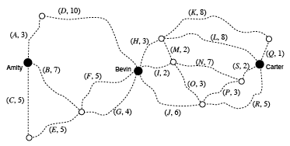
a. Write down the length of the shortest path from Amity to Bevin in kilometres.

b. Draw this shortest path on the map above.

The Amity Cycling Club conducts a race beginning at Amity with checkpoints at every node in this network. The race covers the full length of every road on the network in any order or direction chosen by the riders. A rider may pass through each checkpoint more than once, but must travel along each road exactly once.

c. One competitor claims this cannot be done. By referring to the degrees of the
nodes in this network of roads, explain why it is possible to travel every road
once only when cycling according to the club’s rules.

d. Write down the roads leading to the intersection where, under the club’s rules
for the race, the finish line must be.

e. One competitor begins his race along roads A–D–I–M–H in that order. To
continue the race, which road should this competitor avoid at the end of road
H ? Justify your answer.

For 2009, the club wants to start the race at Amity and finish at Carter over the shortest route that still requires riders to ride the full length of every road in this network. The rules will be modified to allow riders to travel twice along one of the roads.

f. Which road must be travelled twice in 2009 ?

A suggestion for the proposed race in 2009 is to permit riders to travel along roads only in a specified direction between Amity and Bevin. For this section of the race, the suggested directions for roads C, D and F are as shown by arrows on the map section below.

g. On this map section, clearly draw in the correct direction for each of the other
roads.
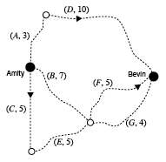

The Water Authority wants to lay water mains along the roads in order to put a fire hydrant at every node on the network shown on this map section. It decides that a minimal spanning tree for this network is suitable.

h. On the map section below, draw in a minimal spanning tree for this network.
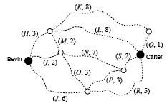
Each week, Andrew, who lives in Bevin, must travel through this network to inspect each of the fire hydrants and then return to Bevin.

i. Write down, in order, the road sections that Andrew must travel to complete a circuit of shortest length, beginning at Bevin. He does this by travelling along a circuit that prevents him from traveling along any road more than once.  j. Write down the total length of this  shortest circuit in kilometres. | 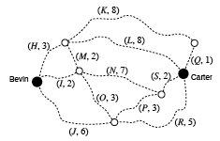

SESSION TWO
The network diagram below shows the location of a warehouse, W. This warehouse supplies equipment to six factories A, B, C, D, E and F. The numbers on the edges indicate the shortest distance (in kilometres) to drive along each of the connecting roads.
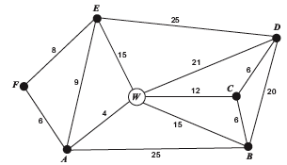

a. Write down the degree of vertex W.

b. A delivery van is at factory B. It must first make a delivery to factory D and
then drive to the warehouse, W. Determine the minimum distance travelled on
this journey.

A salesman plans to leave factory E, first visit the warehouse, W, and then visit every other factory. He is to visit each location only once. He will not return to factory E.

c. Write down the mathematical term used to describe the route that he plans to
take.

d. On the network diagram below, mark in a complete route for his planned
journey.
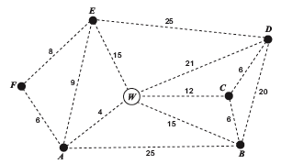

The company plans to build an office along one of the roads in the network. The manager wishes to drive along a route through the network which follows an Euler circuit. She will
start at the warehouse, W.

e. Explain why the journey that the manager plans to take is not possible for this
network.

A journey that follows an Euler path, starting at the warehouse, W, is possible for this network.

f. At which vertex will this Euler path end?

One of the delivery vans has to be repaired.
This repair usually involves every activity shown in the network diagram below. The duration of each activity, in minutes, is also shown.
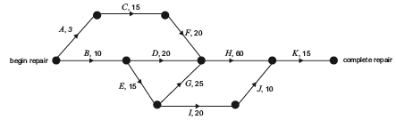
The incomplete table below shows this same information and includes predecessor activities and the earliest starting times (EST).

Activity | Predecessor(s) | Duration of activity  (minutes) | Earliest starting time  EST (minutes)
A |  | 3 | 0
B |  | 10 | 0
C | A | 15 | 3
D | B | 20 | 10
E | B | 15 | 10
F | C | 20 | 18
G | E | 25 | 25
H |  | 60
I | E | 20 | 25
J | I | 10 | 45
K | H, J | 15 | 110

g. Complete the two shaded cells for activity H in the table above.

h. All activities are required for this repair. What is the minimum time needed to
complete this repair?

During the repair to this delivery van it is found that activity F will take longer than the usual 20 minutes.

i. Explain why the duration of activity F can be increased without delaying this
repair.

j. What is the maximum duration of activity F that will not delay completion of
this repair?

Unfortunately further complications arise with this repair. Activity F will now take 40 minutes and activity J will now take 65 minutes. The network diagram below shows the increased duration of these activities.
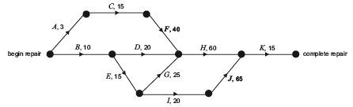
The mechanic also finds that activity J now cannot start until activity G has been completed.

k. Construct a new network diagram to allow for this latest requirement.

l. What is the latest starting time (LST) for activity H that will not further delay
completion of this repair?

m. From beginning to completion, what is the minimum time needed to repair this
delivery van?

Several activities for this repair can be delayed without increasing the minimum completion time.

n. Which of these activities can be delayed for the longest time?

SESSION THREE
The network diagram shows the distances, in kilometres, along a series of roads that connect a quarry, Q, with worksites shown as nodes. One of these worksites is labelled as W.
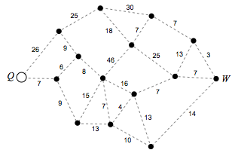
a. On the diagram above, clearly draw in the shortest path from the quarry to W.

b. Determine the length, in kilometres, of the shortest path between the quarry Q
and the worksite W.

The engineer at the quarry wants to visit all worksites in the network. Beginning at Q, he wants to pass through each worksite only once before returning to the quarry.

c. What mathematical term describes the route the engineer wants to take?

d. On the diagram below, clearly draw in a complete route that the engineer
could take to visit each worksite only once before returning to the quarry.

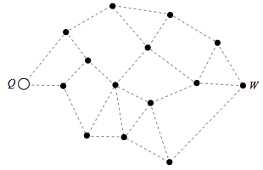

All the activities and their durations (in hours) in a project at the quarry are shown in the network diagram below. The least time required for completing this entire project is 30 hours.
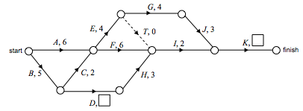
For each activity in this project, Table 1 shows the Completion time, the Earliest starting time and the Latest starting time.

Table 1. Activity Table
Activity | Completion time (hours) | Earliest starting time (hours) | Latest starting time (hours)
A | 6 | 0
B | 5 | 0 | 0
C | 2 | 5 | 5
D |  | 5 | 9
E | 4 | 7 | 7
F | 6 | 7
G | 4 | 11 | 11
H | 3 | 9 | 13
I | 2 | 13 | 16
J | 3 | 15 | 15
K |  | 18 | 18

e. Complete the missing times in Table 1.

f. Write down the critical path for this project.

To speed up the project, several activities can be dropped from the project. The diagram below shows the activities that must remain in this modified version of the project and their usual completion times.
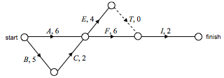
g. Determine the shortest time in which this modified project can be completed.

The completion time of some of the remaining activities in the modified project can be reduced at a cost. Table 2 shows the reduced times (least possible time to complete an activity after maximum reduction of time). The cost of this reduction, per hour, is also shown.

Table 2. Reduced times and costs
Activity | Usual completion time (hours) | Reduced time (hours) | Cost of reduction per hour ($)
A | 6 | 3 | 50
B | 5 | 4 | 100
C | 2 | 2
E | 4 | 2 | 20
F | 6 | 4 | 50
I | 2 | 2 | –

For this modified project, determine :

h. the activities that should be reduced in time to minimise the completion time
of the project.

i. the maximum time, in hours, that can be saved by this reduction.

j. the minimum cost to achieve this time saving.

