Year 11

General Mathematics 2017

Strand: Arithmetic and Number

In this area of study students cover matrices, graphs and networks, and number patterns and recursion, and their use to model practical situations and solve a range of related problems.

Topic 6 – Sequences

This topic includes:
Number patterns and sequences
- the concept of a sequence as a function
- use of a first-order linear recurrence relation to generate the terms of a number sequence
- tabular and graphical display of sequences.
The arithmetic sequence
- generation of an arithmetic sequence using a recurrence relation, tabular and graphical display; and the rule for the nth term of an arithmetic sequence and its evaluation
- use of a recurrence relation to model and analyse practical situations involving discrete linear growth or decay such as a simple interest loan or investment, the depreciating value of an asset using the unit cost method; and the rule for the value of a quantity after n periods of linear growth or decay and its use.
The geometric sequence
- generation of a geometric sequence using a recurrence relation and its tabular or graphical display; and the rule for the nth term and its evaluation
- use of a recurrence relation to model and analyse practical situations involving geometric growth or decay such as the growth of a compound interest loan, the reducing height of a bouncing ball, reducing balance depreciation; and the rule for the value of a quantity after n periods of geometric growth or decay and its use.
The Fibonacci sequence
- generation of the Fibonacci and similar sequences using a recurrence relation, tabular and graphical display
- use of Fibonacci and similar sequences to model and analyse practical situations.

Key knowledge
- the concept of sequence as a function and its recursive specification
- the use of a first-order linear recurrence relation to generate the terms of a number sequence including the special cases of arithmetic and geometric sequences; and the rule for the nth term, tn, of an arithmetic sequence and a geometric sequence and their evaluation
- the use of a first-order linear recurrence relation to model linear growth and decay, including the rule for evaluating the term after n periods of linear growth or decay
- the use of a first-order linear recurrence relation to model geometric growth and decay, including the use of the rule for evaluating the term after n periods of geometric growth or decay
- Fibonacci and related sequences and their recursive specification.

Key skills
- use a given recurrence relation to generate an arithmetic or a geometric sequence, deduce the rule for the nth term from the recursion relation and evaluate
- use a recurrence relation to model and analyse practical situations involving discrete linear and geometric growth or decay
- formulate the recurrence relation to generate the Fibonacci sequence and use this sequence to model and analyse practical situations.

Chapter Sections | Questions to be completed
6.2 Arithmetic sequences | 1,2,3,5,6,7,8,9,10,12,15,17,19,21,22,23,25,26.
6.3 Geometric sequences | 1,2,3,4,5,6,9,10,12,14,16,17,18,19,22,24.
6.4 Recurrence relations | 1,2,3,4,5,6,7,8,9,10,11,12,13,14,15,16,17,19,21.

6.2 Arithmetic Sequences
A sequence is a related set of objects that follow each other in a particular order, often represented by an ordered set of data or numbers.

A sequence may have a finite length. That is a starting number and an ending number.
Example:
- 1, 2, 3, 4, 5, 6, 7, ….., 12 represents the sequential values of the months in a year.

A sequence may have an infinite length. That is it would have a starting number but no ending number.
Example:
- 1, 3, 5, 7, 9…. Represents the sequential values of the odd set of numbers.

In mathematics sequences are always ordered and a mathematical formula can be used to identify the link between each term in the sequence, and to find subsequent terms in the sequence. Each number in the sequence is referred to as a term value and the position of each number is called the term number.

In general, mathematical sequences can be displayed as:

t₁, t₂, t₃, t₄, t₅, t₆….t_{n}

Where t₁ is term 1 (1st term), t₂ is term 2 (2nd term) and so on. n represents the ordered position of the term in the sequence for example 1st, 2nd, 3rd…The first number in a sequence, t₁, is also known as a.

Sequences expressed as functions
If we are able to use the term number in a given formula to find the actual value of the term, the sequence is referred to as a function. The term number we substitute in to the formula is referred to as the input, and the value of the term referred to as the output.

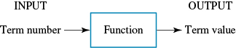

This means we would be able to find the value of any term in the sequence simply by substituting in the number corresponding with the position we want to find.

Example 1: Determine the first 5 terms of the sequence t_{n} = 2n + 3

n = 1, | t₁ = _____________________________________
n = 2, | t₂ = _____________________________________
n = 3, | t₃ = _____________________________________
n = 4, | t₄ = _____________________________________
n = 5, | t₅ = _____________________________________

The first give terms of the sequence are: ___________________________________________

Arithmetic Sequences
An arithmetic sequence is one in which the difference between two consecutive terms is the same. In other words, the next term in the sequence is found by adding or subtracting the same number repeatedly.

Example: Consider the arithmetic sequence below.

2, 5, 8, 11, 14….

- The difference between consecutive terms is _______. This is known as the _______________ _______________ and is symbolised by ______. In this case d = 3, then the consecutive terms in the sequence is calculated by __________________ 3 each time. However in the case when d might be any other number, then the consecutive terms for that sequence can be calculated by either _____________ or _________________ that number each time.
- The first term in the arithmetic sequence is also referred as ______. In the above example,
a = ______.
- The terms of the arithmetic sequence are labelled as t₁, t₂, t₃,…, t_{n}. In the above example,
t₁ = ____________, t₂ = ____________, t₃ = ____________ and t_{n} = __________________.

In order to determine whether a sequence is an arithmetic sequence, a common difference must be established.

Example 2: Determine which of the following sequences are arithmetic sequences, and for those sequences which are arithmetic, state the values of a and d.

- 2, 5, 8, 11, 14, …

t₂ ₋ t₁ = __________________________________
t₃ ₋ t₂ = __________________________________
t₄ − t₃ = _________________________________
t₅ − t₄ = _________________________________

Since the sequence has the same common difference, d = _____, therefore the sequence is arithmetic with a = _____.

- 4, −1, −6, −11, −16, …

t₂ ₋ t₁ = __________________________________
t₃ ₋ t₂ = __________________________________
t₄ − t₃ = _________________________________
t₅ − t₄ = _________________________________

Since the sequence has the same common difference, d = _____, therefore the sequence is arithmetic with a = _____.

- 3, 5, 9, 17, 33, …

t₂ ₋ t₁ = __________________________________
t₃ ₋ t₂ = __________________________________
t₄ − t₃ = _________________________________
t₅ − t₄ = _________________________________

Since the sequence does _______ have the same common difference d, therefore the sequence is _______ an arithmetic.

Equations representing arithmetic sequences
Any arithmetic sequence can be expressed by the equation

t_{n} = a + (n − 1) d

Where t_{n} is the n^{th} term, a is the first term and d is the common difference

Example 3: Determine the equations that represent the following arithmetic sequences.

- 3, 6, 9, 12, 15, …
a = _______ d = _________________________
t_{n} = a + (n – 1)d

- 40, 33, 26, 19, 12, …
a = _______ d = _________________________
t_{n} = a + (n – 1)d

Determining future terms of an arithmetic sequence
After an equation has been set up to represent an arithmetic sequence, we can use this equation to determine any term in the sequence. Simply substitute the value of n into the equation to determine the value of that term.

Example: Use the rules/equations that represent the two sequences in example 3 to determine the value of the 10th term.

- t_{n} =  t₁₀ = | - t_{n} =  t₁₀ =

Determining other values of an arithmetic sequence
After an equation has been set up it can be used to determine and term in the series. We can also rearrange the equation to find any other unknown value, a, d, or n.

- $a=t_{n}-\left(n-1\right)d$
- $d=\frac{t_{n}-a}{n-1}$
- $n=\frac{t_{n}-a}{d}+1$

Example 4:
- Find the 15th term of the sequence 2, 8, 14, 20, 26, …

- Find the first term of the arithmetic sequence in which t₂₂ = 1008 and d = −8.

- Find the common difference of the arithmetic sequence which has a first term of 12 and 11th term of 102.

- An arithmetic sequence has a first term of 40 and a common difference of 12. Which term number has a value of 196?

Graphical displays of arithmetic sequences
Since an arithmetic sequence involves adding or subtracting the same value repeatedly known as the _______________ _______________. The relationship between the terms is therefore linear, that is it formed a ______________ _______________.

Example 5: An arithmetic sequence is given by the equation $t_{n}=7+2(n-1)$

- Draw up a table of values showing the term number and term value for the first 5 terms of the sequence.

Term number | 1 | 2 | 3 | 4 | 5
Term value

n = 1, t₁ = _________________________ | n = 4, t₄ = _________________________
n = 2, t₂ = _________________________ | n = 5, t₅ = _________________________
n = 3, t₃ = _________________________

When representing numerical sequence graphically, the term number, n, is placed along the x-axis while the term value is placed along the y-axis.

- Graph the values from the table.
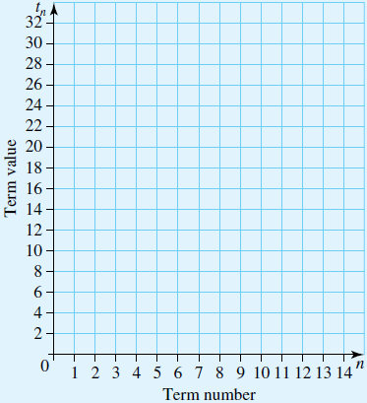

- Using the graph, determine the value of the 12th term in the sequence.

Modelling practical situations

Simple Interest
Simple Interest is a fixed amount of interest which gets added on to an original amount of money at equal intervals over a period of time. It is calculated using the following formula

$$I=\frac{PrT}{100}$$

$I=$ Simple Interest
$P=$ Principal (Initial amount)
$r=$ Percantage rate
$T=$ The amount of periods

Example 6: Jelena puts $1000 into an investment that earns simple interest at a rate of 0.5% per month.
- Set up an equations that represents Jelena’s situation as an arithmetic sequence, where t_{n} is the amount in Jelena’s account after n months.

- Use your equation from part (a) to determine the amount in Jelena’s account at the end of each of the first 6 months.

n = 1, t₁ = ________________________________________________________________
n = 2, t₂ = ________________________________________________________________
n = 3, t₃ = ________________________________________________________________
n = 4, t₄ = ________________________________________________________________
n = 5, t₅ = ________________________________________________________________
n = 6, t₆ = ________________________________________________________________

- Calculate the amount in Jelena’s account at the end of 18 months

n = 18, t₁₈ = ______________________________________________________________

Depreciating assets
Many items, such as electronic equipment, depreciate in value over time as a result of wear and tear. Unit cost depreciation is a way of calculating the value of depreciation according to its use. For example, the value of a cars depreciation is based on how many kilometres it has driven. The value of an item at any given time can be calculated and is referred to as its future value.

The write-off value or scrap value of an asset is the point at which the asset is effectively worthless, that is when the value is equal to $0 due to depreciation.

Example 7: Loni purchases a new car for $25000 and decides to depreciate it at a rate of $0.20 per km.
- Set up an equation to determine the value of the car after n km of use.

- Use your equation from part (a) to determine the future value of the car after it has 7500km on its clock.

6.3 Geometric Sequences
First consider the sequence 1, 3, 9, 27, 81, … This is a geometric sequence, as each term is obtained by multiplying the previous term by 3.

Now consider the sequence 1, 3, 6, 10, 15, … This is not a geometric sequence, as the consecutive terms are not multiplying by the same number.

A geometric sequence is a pattern of numbers where the next term in the sequence is formed by multiplying the previous term by a fixed number called the _______________ _______, r.

Example 8: Determine which of the following sequences are geometric sequences, and for those sequences which are geometric, state the values of a and r.

- 20, 40, 80, 160, 320, …

Since the ratios between consecutive terms is _______. Therefore the sequence is ____________________ with a = _______ and r = _______.

- 8, 4, 2, 1, ½ , ...

Since the ratios between consecutive terms is _______. Therefore the sequence is ____________________ with a = _______ and r = _______.

- 3, –9, 27, –81, …

Since the ratios between consecutive terms is _______. Therefore the sequence is ____________________ with a = _______ and r = _______.

- 2, 4, 6, 8, 10, …

Since the ratios between consecutive terms are ________________. Therefore the sequence is __________ geometric.
In general, the next term of the geometric sequence can be obtained by using the following formula.
$$t_{n+1}= t_{n} × r$$

The ratio of the geometric sequence can be calculated by the formula, $r=\frac{t_{n+1}}{t_{n}}$

A geometric sequence can also be written in term of the first term, a, with a common ratio, r.
t_{n} = ar^{n−1}
t₁, | t₂, | t₃, | t₄, | _____ | ….. | t_{n}
a, | ar¹, | ar², | ar³, | _____ | ….. | ar^{n−1}

Example 9: Determine the equations that represent the following geometric sequences.
- 7, 28, 112, 448, 1792, …

- 8, −4, 2, −1, ½ , …

Determining other values of a geometric sequence
The values for a and r for a geometric sequence can be found by transposing the equation.

- $a=\frac{t_{n}}{r^{n-1}}$

- $r={\left(\frac{t_{n}}{a}\right)}^{\frac{1}{n-1}}$

Example 10:
- Find the 20th term of the geometric sequence with $a=5$ and $r=2.$

- A geometric sequence has a first term of 3 and a 20th term of 1572864. Find the common ration between the consecutive terms of the sequence.

- Find the first term of a geometric series with a common ratio of 2.5 and a 5th term of 117.1875

Graphs of geometric sequences
The shape of the graph of a geometric sequence depends on the value of r.
- When r > 1, the values of the terms increase of decrease at an exponential rate.
- When 0 < r < 1, the values of the terms converge towards zero.
- When −1 < r < 0, the values of the terms oscillate on either side of zero but converge towards zero.
- When r < −1, the values of the terms oscillate on either side of zero and move away from the starting value at the exponential rate.

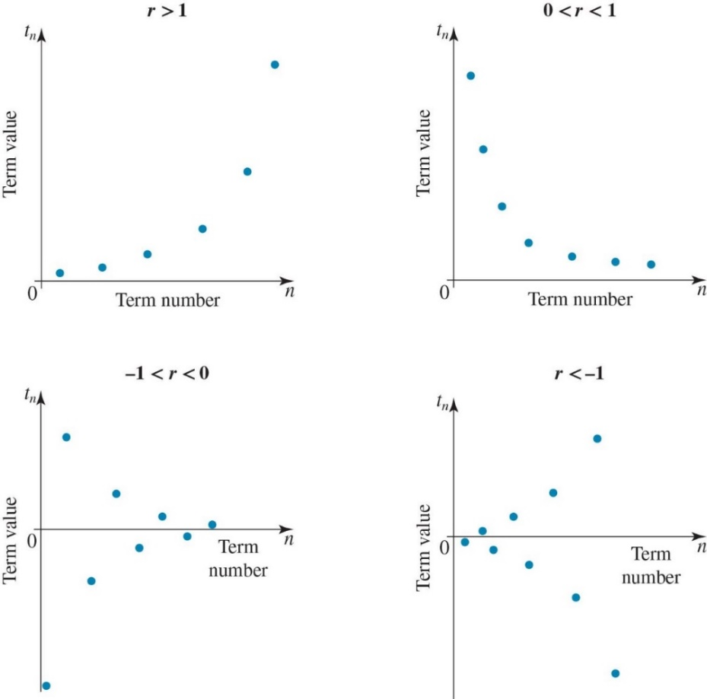
Example 11: A geometric sequence is defined by the equation $t_{n}=5×2^{n-1}$
- Draw up a table of values showing the term number and the term value for the first 5 terms of the sequence

Term number | 1 | 2 | 3 | 4 | 5
Term value

n = 1, t₁ = _________________________ | n = 4, t₄ = _________________________
n = 2, t₂ = _________________________ | n = 5, t₅ = _________________________
n = 3, t₃ = _________________________

- Plot the graph of the sequence.

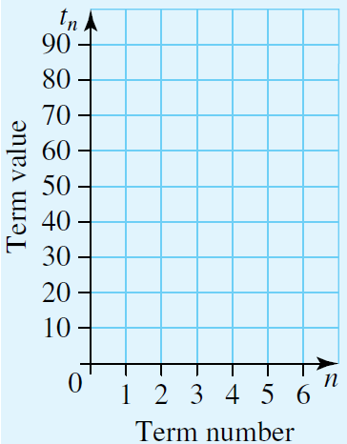

Using geometric sequences to modelling practical situations

Compound Interest
Compound interest is calculated on the sum of the investment at the start of each compounding period. The amount of interest varies based on how long the investment period lasts, and can be modelled through a geometric sequence. It can be calculated using the following formula:
$$A={P\left(1+\frac{r}{100}\right)}^{n}$$
$A=$ Compound Interest
$P=$ Principal (initial amount)
$r=$ Percentage rate
$n=$ Number of compounding periods

Example 12: Alexis puts $2000 into an investment account that earns compound interest at a rate of 0.5% per month.
- Set up an equation that represents Alexis’ situation as a geometric sequence, where $t_{n}$ is the amount in Alexis’ account after $n$months.

- Use your equation from part (a) to determine the amount in Alexis’ account at the end of each of the first 6 months

t₃ = ________________________________ | t₅ = ________________________________
t₄ = ________________________________ | t₆= ________________________________

The amounts in Alexis’ account at the end of each of the first six months are: ____________
___________________________________________________________________________

- Calculate the amount in Alexis’ account at the end of 15 months
t₁₅ =

Reducing balance depreciation
Reducing balance depreciation occurs where an item deprecia.’tes by a percentage of the previous year value of the item. This can be represented as a geometric sequence.

Example 13: A hot water system purchased for $1250 is depreciated by the reducing balance method at a rate of 8% p.a.
- Set up an equation to determine the value of the hot water system after $n$ years of use.

- Use your equation from part (a) to determine the future value of the hot water system after 6 years of use (correct to the nearest cent).

6.4 Recurrence relations

Using first order linear recurrence relations to generate number sequences
In a recurrence relation, each term in a sequence is dependent on the previous term. This means we must know the first term of the sequence to be able to determine any of the following terms. The $n^{th}$ term in the sequence is represented by $t_{n}$. The term directly after $t_{n}$ is represented by $t_{n+1}$ and the term directly before is represented by $t_{n-1}$. The very first value of the sequence is represented by $t_{1}$.

Example 14: Determine the first five terms of the sequence represented by the recurrence relation $t_{n+1}=2t_{n}+5$, givent that $t_{1}=8.$

n = 1, t₁ = _____________________________ | n = 4, t₄ = _____________________________
n = 2, t₂ = _____________________________ | n = 5, t₅ = _____________________________
n = 3, t₃ = _____________________________

Using a recurrence relation to generate arithmetic sequences
If we know the values of a (the first term) and d (the common difference), we can set up a recurrence relation to generate the sequence. The recurrence relation representing an arithmetic sequence will be in the form
$t_{n+1}=t_{n}+d$ where $t_{1}=a$.

Example 15: Set up a recurrence relation to represent the arithmetic sequence −9, −5, −1, 3, 7.

Using a recurrence relation to generate geometric sequences

If we know the values of a and r in a geometric sequence, we can set up a recurrence relation to generate the sequence. It will be of the form

$t_{n+1}=t_{n} ×r={rt}_{n}$ where $t_{1}=a$.

Example 16: Set up a recurrence relation to represent the sequence 10, 5, 2.5, 1.25, 0.625…

Using recurrence relations to model practical situations
When there is a situation that can be modelled by an arithmetic or geometric sequence, we can use a recurrence relation to model it. We first need to determine if the sequence is arithmetic or geometric.

Spotting arithmetic sequences
Arithmetic sequences are sequences that involve linear growth or decay. Some examples include simple interest loans or investments or the number of flowers left in a field if the same amount is harvested each day.

Spotting geometric sequences
Geometric sequences are sequences which involve geometric growth or decay. Examples include the reducing height of a bouncing ball or the number of bacteria in a culture after a number of periods of time. Wherever percentages are involved to generate numbers to create a sequence, it is a geometric sequence. For a percentage increase (x), the value of the common ratio, r, will be $\left(1+\frac{x}{100}\right)$. For a percentage decrease (x), the value of the common ratio, r, will be $\left(1-\frac{x}{100}\right)$.

Example 17: According to the International Federation of Tennis, a tennis ball must meet certain bounce regulations. The test involves the dropping of a ball vertically from a height of 254cm and then measuring the rebound height. To meet the regulations, the ball must rebound 135cm to 147cm, just over half the original distance.

Janine decided to test the ball bounce theory out. She dropped a ball from a height to 200cm. She found that it bounced back up to 108cm, with the second rebound reaching 58.32cm and the third rebound reaching 31.49cm.

- Set up a recurrence relation to model the bounce height of the ball.

- Use your relation from part (a) to estimate the height of the 4th and 5th rebounds, giving your answers correct to 2 decimal places.

- Sketch the graph of the number of bounces against the height of each bounce.

No. of rebounds | 1 | 2 | 3 | 4 | 5
Rebound height (cm)

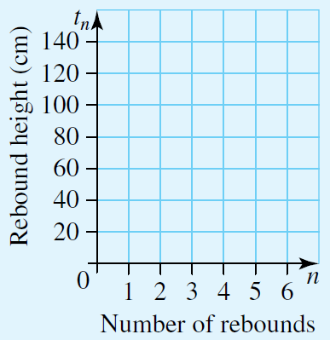

The Fibonacci sequence
The Fibonacci sequence begins with two 1’s, and every subsequent term of the sequence is found by adding the two previous terms, giving the sequence:

1, 1, 2, 3, 5, 8, 13, 21, 34, 55, 89, 144, 233…

As the Fibonacci sequence depends on two previous terms to find the next one, instead of one, it is referred to as a second order recurrence relation. It can be represented by the recurrence relation:

$$F_{n+2}=F_{n}+F_{n+1}, F_{1}=1, F_{2}=1$$

The Golden Ratio
The ratio between consecutive terms of the Fibonacci sequence in not a fixed ratio, unlike what is seen in a normal geometric sequence. However, the ratios do converge on a number that has special mathematical significance.

The number that the ratios converge to is known as the Golden Ratio. Its exact value is $\frac{1+\sqrt{5}}{2}$
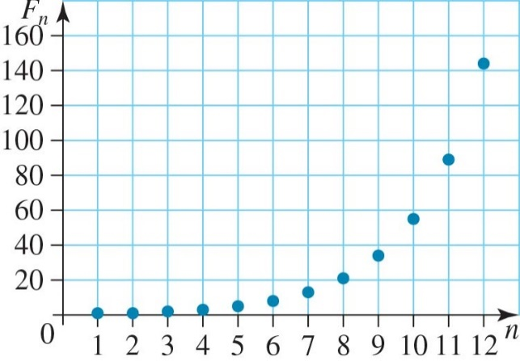
If you plot the term numbers of the Fibonacci sequence against the term values, the pattern forms a smooth curve, similar to the graphs of a geometric sequence.

Variations of the Fibonacci sequence
The standard sequence begins with two 1’s, but as soon as the two first terms are changed, we get alternative versions of the Fibonacci sequence. For example if the first two numbers are 2 and 5, the sequence becomes: 2, 5, 7, 12, 19, 31, 50, 81, 131…

Example 18: State the first 8 terms of the variation for the Fibonacci sequence given by the recurrence relation:

$$F_{n+2}=F_{n}+F_{n+1}, { F}_{1}=-1, { F}_{2}=5$$

F₁ =
F₂ =
F₃ =
F₄ =
F₅ =
F₆ =
F₇ =
F₈ =
The first 8 terms of the sequence are: ____________________________________________

