

Further Mathematics 2016

**Core:** Recursion and Financial modelling

Chapter 5 - Recurrence Relations

# Extract from Study Design

**Key knowledge**

• the concept of a first-order linear recurrence relation and its use in generating the terms in a sequence

• uses of first-order linear recurrence relations to model growth and decay problems in financial contexts

**Key skills**

• use a given first-order linear recurrence relation to generate the terms of a sequence

• model and analyse growth and decay in financial contexts using a first-order linear recurrence relation of the form *u*0 = *a*, *un*+1 = *bun* + *c*

|  |  |
| --- | --- |
| **Chapter Sections** | **Questions to be completed** |
| **5.1** Sequences | In the notes |
| **5.2** Generating the terms of a first-order recurrence relations | In the notes |
| **5.3** First-order linear recurrence relations | 1, 2, 3, 4, 5, 6, 7, 8, 9gh, 11cd, 13, 14gh, 16ef, 18de |
| **5.4** Graphs of first-order recurrence relations | 1, 2, 3, 4, 5, 6, 7, 8, 9, 10, 11bc, 12, 13, 17, 18 |



**More resources available at**

http://pcsfurthermaths.weebly.com

Table of Contents

Chapter 5 - Recurrence Relations 1

Extract from Study Design 1

5.1 Sequences 3

Using a calculator to generate a sequence of numbers from a rule 4

Exercise 5.1: Generating a sequence recursively 5

5.2 Generating the terms of a first-order recurrence relations 6

The importance of the Starting Term 7

Finding other Terms in a recurrence relation 7

Example 6 8

Example 6: Using CAS Calculator 8

Exercise 5.2 Generating the terms of first-order recurrence relations 9

5.3 First-order linear recurrence relations 11

First-order linear recurrence relations with a common difference 11

Worked Example 4 11

Worked Example 4: Using CAS Calculator 12

First-order linear recurrence relations with a common ratio 13

Worked Example 6 13

Worked Example 7 14

Worked Example 7 Using CAS Calculator 14

Modelling linear growth and decay 16

A recurrence model for linear growth and decay 16

5.4 Graphs of first-order recurrence relations 17

First-order recurrence relations: un+1 = un + b (arithmetic patterns) 17

Worked Example 8 17

Worked Example 8: Using the CAS calculator 18

First-order recurrence relations: un+1 = Run 18

Worked example 9 18

Worked example 9: Using CAS calculator 19

Interpretation of the graph of first-order recurrence relations 20

Worked Example 10 21

Worked Example 11 21

Worked Example 12 21

5.1 Sequences

A list of numbers, written down in succession, is called a sequence. Each of the numbers in a sequence is called a term. We write the terms of a sequence as a list, separated by commas. If a sequence continues indefinitely, or if there are too many terms in the sequence to write them all, we use an *ellipsis*, ‘. . . ’, at the end of a few terms of the sequence like this:

12, 22, 5, 6, 16, 43, ...

The terms in this sequence of numbers could be the ages of the people boarding a plane.

The age of these people is random so this sequence of numbers is called a *random sequence*. There is no pattern or rule that allows the next number in the sequence to be predicted.

Some sequences of numbers do display a pattern. For example, this sequence

1, 3, 5, 7, 9, . . .

has a definite pattern and so this sequence is said to be *rule-based*.

The sequence of numbers has a starting value. We add 2 to this number to generate the term 3.

Then, add 2 again to generate the term 5, and so on. The rule is ‘add 2 to each term’.

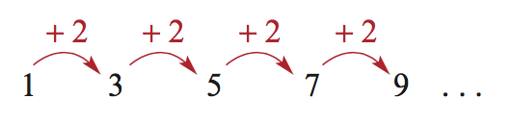

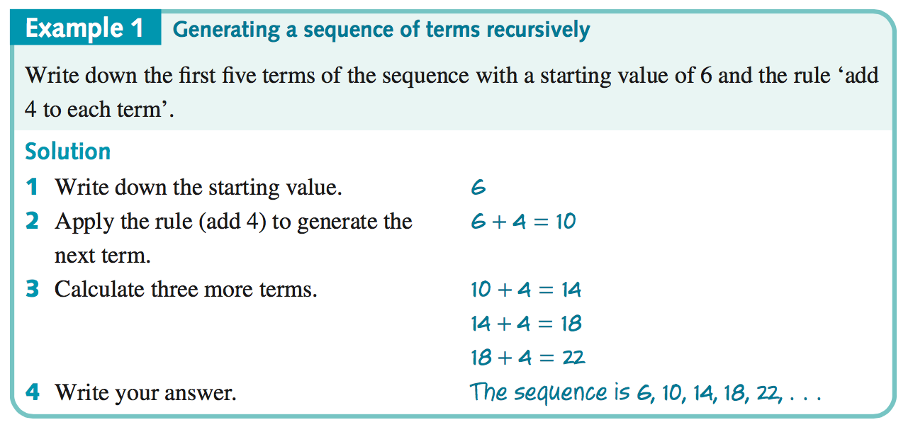

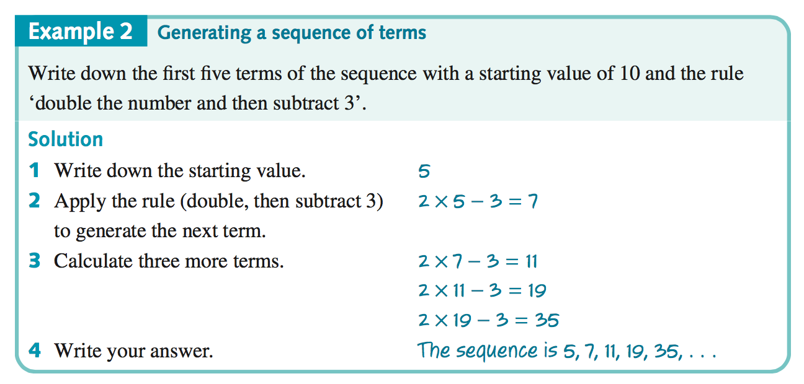

# Using a calculator to generate a sequence of numbers from a rule

All of the calculations to generate sequences from a rule are repetitive. The same calculations are performed over and over again – this is called *recursion*. A calculator can perform recursive calculations very easily, because it automatically stores the answer to the last calculation it performed, as well as the method of calculation.

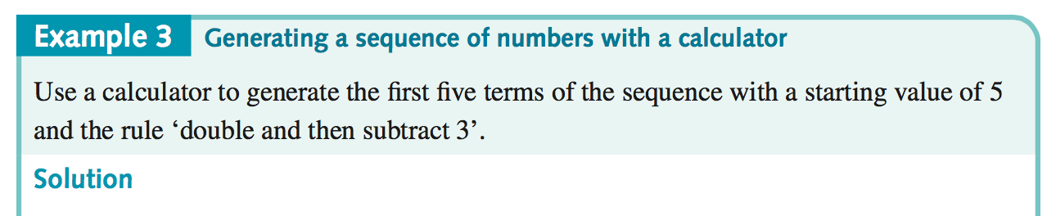

|  |  |  |
| --- | --- | --- |
| Start with a blank calculator page  Press   * c Home * 1 New document * 1 add calculator |  |  |
| * Type 5 5 * press enter · |  | Starting  term |
| Next   * type r2-3 |  | Starting  term  Equation |
| Press enter ·  Note: when you press enter, the CAS converts ans to the value of the previous answer (in this case 5) |  |  |
| Pressing · repeatedly applies the rule “x2-3” to the last calculated value, in the process generating successive terms of the sequence as shown. |  | 1st term  2nd term  3rd term  4th term  5th term |

# Exercise 5.1: Generating a sequence recursively

**1** Use the following starting values and rules to generate the first five terms of the following sequences recursively ***by hand***.

**a)** Starting value: 2 rule: add 6 **b)** Starting value: 5 rule: subtract 3

**c)** Starting value: 1  rule: multiply by 4 **d)** Starting value: 10 rule: divide by 2

**e)** Starting value: 6 rule: multiply by 2 add 2 **f)** Starting value: 12 rule: multiply by 0.5 add 3

**2** Use the following starting values and rules to generate the first five terms of the following sequences recursively ***using a CAS calculator***.

**a)** Starting value: 4 rule: add 2 **b)** Starting value: 24 rule: subtract 4

**c)** Starting value: 2 rule: multiply by 3 **d)** Starting value: 50 rule: divide by 5

**e)** Starting value: 5 rule: multiply by 2 add 3 **f)** Starting value: 18 rule: multiply by 0.8 add 2

5.2 Generating the terms of a first-order recurrence relations

A **first-order recurrence relation** relates a term in a **sequence** to the previous term in the same sequence. To generate the terms in the sequence, only the **initial term** is required.

A recurrence relation is a mathematical rule that we can use to generate a sequence. It has two parts:

1. a *starting point*: the value of one of the terms in the sequence
2. a *rule* that can be used to generate successive terms in the sequence.

For example, in words, a recursion rule that can be used to generate the sequence: 10, 15, 20 ,... can be written as follows:

1. Start with 10.
2. To obtain the next term, add 5 to the current term and repeat the process.

A more compact way of communicating this information is to translate this rule into symbolic form. We do this by defining a subscripted variable. Here we will use the variable *Vn*, but the *V* can be replaced by any letter of the alphabet.

Let *Vn* be the term in the sequence *after n* iterations[1]*.

Using this definition, we now proceed to translate our rule written in words into a mathematical rule.

|  |  |  |
| --- | --- | --- |
| Starting value  (n=0) | *Rule for generating the next term* | Recurrence relation  (two parts: starting value plus rule) |
| V0=10 | Vn+1=Vn+5  Next term =current term +5 | V0=10 Vn+1=Vn+5  Starting value rule |

**Note:** Because of the way we defined *Vn*, the starting value of *n* is 0. At the start there have been no applications of the rule. This is the most appropriate starting point for financial modelling.

The key step in using a recurrence relation to generate the terms of a sequence is to be able to translate the mathematical recursion rule into words.

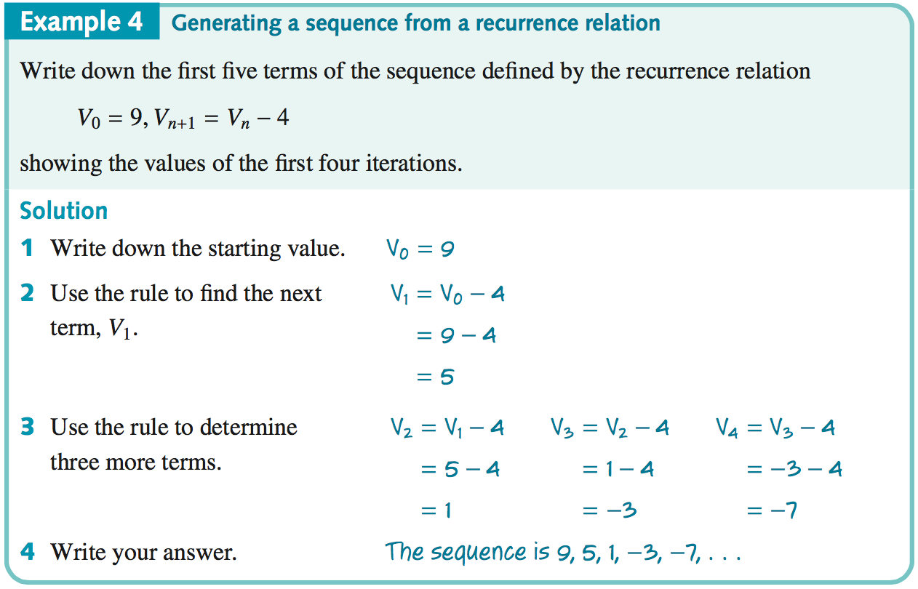

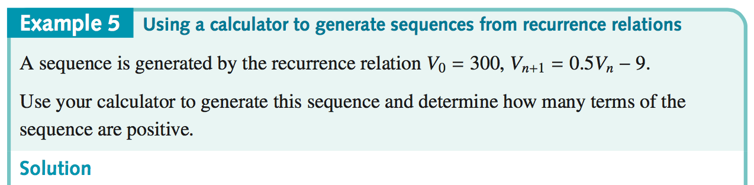

|  |  |
| --- | --- |
| Start with a blank calculator page  Press   * c Home * 1 New document * 1 add calculator |  |
| * Type 300 300 * press enter ·   Next   * Type r0^5-9 * press enter ·   Continue to press ·until the first negative term appears and write your answer:  The first 5 terms of the sequence are positive. |  |

# The importance of the Starting Term

In the examples above, If the **same rule** is used with a different starting point, it will generate different sets of numbers.

Example 4 V0=9, Vn+1=Vn-4 The first five terms were: 9, 5, 1, -3, -7

If V0 =8 then, the first 5 terms would be: 8, 4, 0, -4, -8

Example 5 V0=300, Vn+1=0.5Vn-9 The first five terms were: 300, 141, 61.5, 21.75, 1.875

If V0 =250 then, the first 5 terms would be: 250, 116, 49, 15.5, -1.25

# Finding other Terms in a recurrence relation

We can also use recurrence relations to find previous terms, but we need two pieces of information

1. The rule, in terms of Vn+1 and Vn
2. The term number and its value. i.e. n=2 and V2=10 (note if n=0, 1, 2, … then n=2 is the 3rd term)

## Example 6

A sequence is defined by the first-order recurrence relation:

Un+1 = 2Un - 3 n = 0, 1, 2, 3, …

If the fifth term of the sequence is -29, that is U4 = -29, then what is the third term (U2)?

|  |  |  |
| --- | --- | --- |
| Example 6: Using CAS Calculator |  | |
| **1.** Use the solve function to re-arrange the equation for the 3rd term.   * Enter solve(u4=2xu3-3,u3)   solve(U4=2rU3-3,U3)   * Press enter · |  | u3 in terms of u4 |
| Now enter the 4th term   * Type v29·   Now enter the equation for the 3rd term, in terms of the 4th term found above.   * /p for $\frac{[ ]}{\left[ \right]}$* then /v+3   2  **Note:** /v gives “Ans” the previous answer |  | 4th term  equation for 3rd term |
| * Press enter ·for the 3rd term |  | 3rd term |
| * Press enter ·for the 2nd term |  | 2nd term |

# Exercise 5.2 Generating the terms of first-order recurrence relations

**Question 1** The following equations define a sequence. Which of them are first-order recurrence relations (defining a relationship between two consecutive terms)?

**a) $u_{0}=7$ $u_{n+1}=u_{n}+6$ $n=0, 1, 2, 3,…$**

**b) $u_{n+1}={5u}_{n}+1$ $n=1, 2, 3$**

**Question 2** The following equations each define a sequence. Which of them are first-order recurrence relations?

**a) $u_{n+1}=4u_{n}-3$ $n=1, 2, 3$**

**b) $f_{0}=0$ $f_{n+1}={5f}_{n}-8$ $n=0, 1, 2, 3,…$**

**Question 3** Without using your calculator, write down the first five terms of the sequences generated by each of the recurrence relations below.

**a)** *W*0 =2, *Wn*+1 =*Wn* +3 **b)** *D*0 =50, *Dn*+1 =*Dn* −5 **c)** *M*0 =1, *Mn*+1 =3*Mn*

**d)** *L*0 =3, *Ln*+1 =−2*Ln*  **e)** *K*0 =5, *Kn*+1 =2*Kn* −1 **f)** *F*0 =2, *Fn*+1 =2*Fn* +3

**g)** *S*0 =−2, *Sn*+1 =3*Sn* +5 **h)** *V*0 =−10, *Vn*+1 =−3*Vn* +5

**Question 4** Using your **CAS** calculator, write down the first five terms of the sequence generated by each of the recurrence relations below.

**a)** *A*0 =12, *An*+1 =6*An* −15  **b)** *Y*0 =20, *Yn*+1 =3*Yn* +25 **c)** *V*0 =2, *Vn*+1 =4*Vn* +3

**d)** *H*0 =64, *Hn*+1 =0.25*Hn* −1 **e)** *G*0 =48000, *Gn*+1 =*Gn* −3000 **f)** *C*0 =25000,*Cn*+1 =0.9*Cn* −550

**Question 5** Write the first five terms of the sequence defined by the first-order recurrence relation:

$u_{0}=5$ $u_{n+1}={4u}_{n}+3$

**Question 6** Write the first five terms of the sequence defined by the first-order recurrence relation:

$f_{0}=-2$ $f_{n+1}={5f}_{n}-6$

**Question 7** A sequence is defined by the first-order recurrence relation:

$u_{n+1}=2u_{n}-1$ $n=0, 1, 2, 3,…$

If the fourth term of the sequence is 5, that is $u_{3}=5$, then what is the 2nd term? (Hint: 2nd term is un, when n=?)

**Question 8** A sequence is defined by the first-order recurrence relation:

$u_{n+1}=3u_{n}+7$ $n=0, 1, 2, 3, 4,…$

If the seventh term of the sequence is 5, that is $u_{6}=34$, then what is the 5th term?

**Question 9** Which of the following equations are complete first-order recurrence relation?

**a) $u_{n+1}=2+n$**

**b) $u_{n+1}=u_{n}-1 u_{0}=2$**

**c) $u_{n+1}={1-3u}_{n} u_{0}=2$**

**d) $u_{n}-{4u}_{n+1}=5$**

**e) $u_{n+1}={-u}_{n}$**

**f) $u_{n+1}=n+1 u_{0}=2$**

**g) $u_{n+1}=1-u_{n} u_{0}=21$**

**h) $u_{n}=a^{n-1 } u_{0}=2$**

**i) $f_{n+1}=3f_{n}-1$**

**j) $p_{n+1}=p_{n}+7 u_{0}=7$**

**Question 10** Write the first five terms of each of the following sequences.

**a) ${u_{0}=6 u}_{n+1}=u_{n}+2$** **b) ${u_{0}=5 u}_{n+1}=u_{n}-3$**

**c) ${u_{0}=23 u}_{n+1}=1+u_{n}$** **d) ${u_{0}=7 u}_{n+1}=u_{n}-10$**

**Question 11** Write the first five terms of the each of the following sequences.

**a) ${u_{0}=1 u}_{n+1}={3u}_{n}$** **b) ${u_{0}=-2 u}_{n+1}=5u_{n}$**

**c) ${u_{0}=1 u}_{n+1}=-4u_{n}$** **d) ${u_{0}=-1 u}_{n+1}={2u}_{n}$**

**Question 12** Write the first five terms of the each of the following sequences.

**a) ${u_{0}=1 u}_{n+1}={2u}_{n}+1$** **b) ${u_{0}=5 u}_{n+1}=3u_{n}-2$**

**Question 13 Multiple Choice** Which of the sequences is generated by the following first-order recurrence relation?

$$u_{0}=2 u_{n+1}=3u_{n}+4$$

**A $2, 3, 4, 5, 6, …$**  **B $2, 6, 10, 14, 18, …$**

**C $2, 10, 34, 106, 322, …$**  **D $2, 11, 47, 191, 767, …$**

**E $-3, -7, -15, -31, -63, …$**

**Question 14** A sequence is defined by the first-order recurrence relation:

$u_{n+1}=4u_{n}-5$ $n=0, 1, 2, 3,…$

If the third term is -41 (that is *u*2=-41), what is the first term?

**Question 15** For the sequence defined in question 14, if the seventh term is -27, what is the fifth term?

5.3 First-order linear recurrence relations

# First-order linear recurrence relations with a common difference

The **common difference**, *d*, is the value between consecutive terms in the sequence:

Look at the sequence 3, 7, 11, 15, 19, ….

*d = u2 – u1 = u3 – u2 = u4 – u3 = …*

*d* = 7 – 3 = 11 – 7 = 15 – 11 = +4

The common difference is +4.

This sequence may be defined by the first-order linear recurrence relation:

un+1 – un = 4 u0 = 3

Rewriting this

un+1 = un +4 u0 = 3

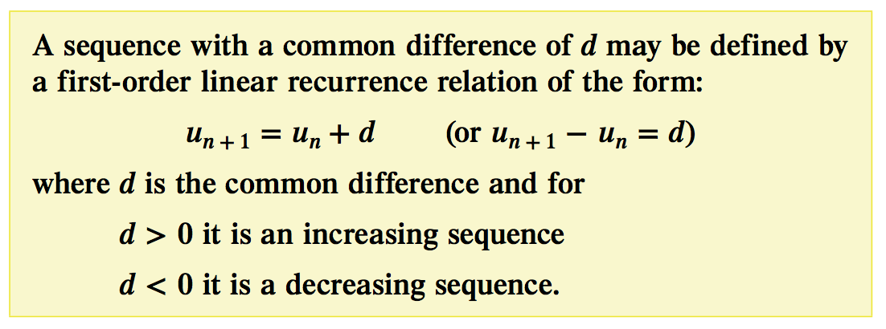

## Worked Example 4

Express each of the following sequences as first-order recurrence relations.

a) 7, 12, 17, 22, 27, …

b) 9, 3, -3, -9, -15, …

|  |  |
| --- | --- |
| Worked Example 4: Using CAS Calculator |  |
| To check if there is a common difference  Use a list and spreadsheet page   * Enter the values in the first column |  |
| * Enter the equation in column B * Check all values are the same |  |
| Repeat for Part b |  |
|  |  |

# First-order linear recurrence relations with a common ratio

Not all sequences have a **common difference** (increasing/decreasing by adding/subtracting the same difference to find the next term).

The sequence may increase/decrease by multiplying the terms by a **common ratio**.

Look at the geometric sequence 1, 3, 9, 27, 81, …

The common ratio can be found by dividing the current term by the previous term. So generally:

$$R= \frac{u_{2}}{u_{1}}= \frac{u_{3}}{u_{2}}= \frac{u_{4}}{u_{3}}=…$$

And in this example:

$$R= \frac{3}{1}= \frac{9}{3}= \frac{27}{9}=…$$

Here the common ratio is 3.

The sequence can be defined by the first-order linear recurrence relation:

un+1 = 3un where: u0 = 1

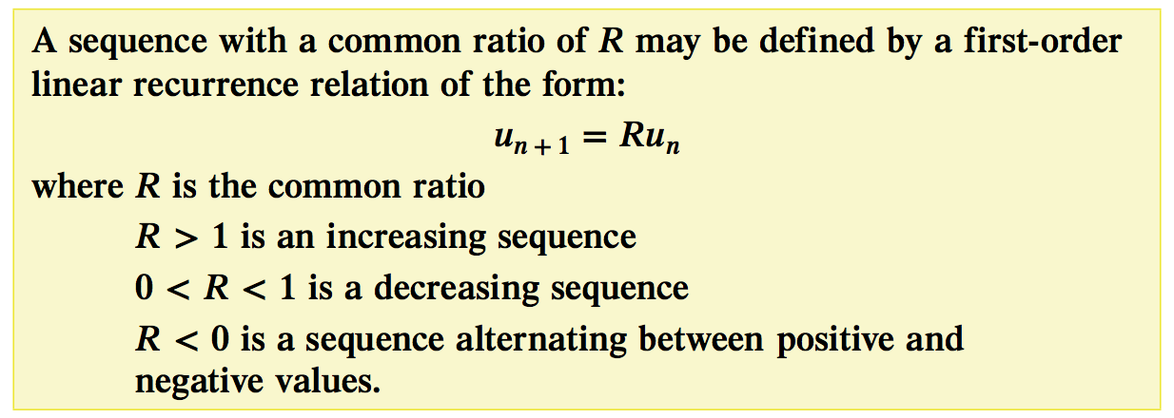

## Worked Example 6

Express each of the following sequences as first-order recurrence relations.

a) 1, 5, 25, 125, 625, ….

b) 3, -6, 12, -24, 48, …

## Worked Example 7

Express each of the following sequences as first-order recurrence relations.

a) un+1 = 2(7)n  n = 0, 1, 2, 3, 4, …

b) un+1 = -3(2)n n = 0, 1, 2, 3, 4, ….

|  |  |
| --- | --- |
| Worked Example 7 Using CAS Calculator |  |
| Part a: un+1 = 2(7)n  n = 0, 1, 2, 3, 4, … |  |
| * Label column A “n” * Enter the n values in column A |  |
| * Label Column B “value” * Enter the equation for un into the equation box of column B, after an = sign * Press · |  |
| To find the common ratio, divide each term by the previous term.   * Enter = $\frac{b2}{b1}$ as shown * Press · |  |
| Now fill down this equation to the cells below.  Press   * Menu b * data 3 * fill 3   This could also be done in the col C formula box |  |

|  |  |  |
| --- | --- | --- |
| Part b: un = -3(2)n-1 n = 0, 1, 2, 3, 4, …. | | |
| Repeat for Part b |  |  |

# Modelling linear growth and decay

Linear growth and decay is commonly found around the world. They occur when a quantity increases or decreases by the same amount at regular intervals. Everyday examples include the paying of simple interest or the depreciation of the value of a new car by a constant amount each year.

[](https://www.youtube.com/watch?v=4gW2wTgW6hM)An example of linear growth is the **investment of money**, such as putting it in a savings account where the sum increases over time.

An example of linear decay is the **money owned** to repay a loan, the sum of money owned will decrease over time. (an example of which is the “Holiday ghost” – Nimble loan ad)

## A recurrence model for linear growth and decay

The recurrence relations

*P*o =20, *Pn*+1 =*Pn* +2 *Q*o =20, *Qn*+1 =*Qn* −2

both have rules that generate sequences with linear patterns, as can be seen from the table below. The first generates a sequence whose successive terms have a linear pattern of growth, and the second a linear pattern of decay.

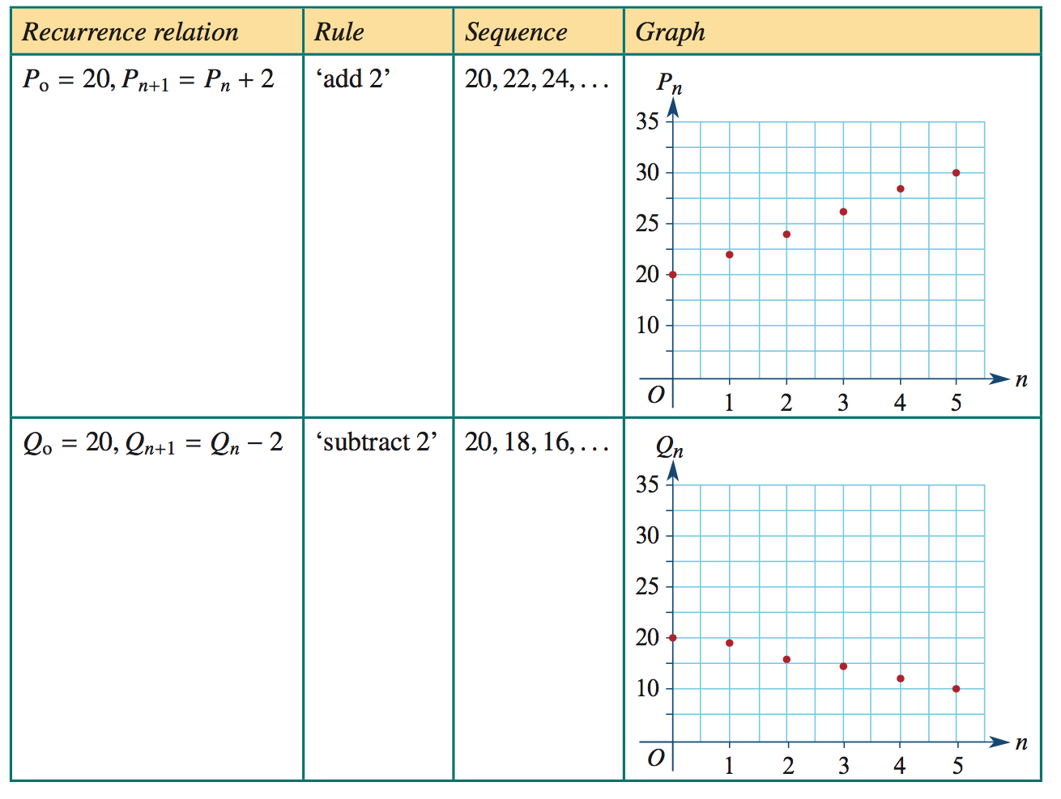

As a general rule, if *D* is a constant, a recurrence relation rule of the form: 􏰀

*Vn*+1 = *Vn* + *D* can be used to model **linear growth**.

*Vn*−1 = *Vn* − *D* can be used to model **linear** **decay**.

*In Chapters 6 and 7 we will use this knowledge to model and investigate simple interest loans and investments, as well as flat rate depreciation and unit cost depreciation of assets. But first, in the next section, we will look at graphing the first-order recurrence relations discussed above.*

5.4 Graphs of first-order recurrence relations

***(Note: In this section the textbook uses n=1, 2, 3, … Instead of n=0, 1, 2, 3, … as they should have in line with the VCAA study design.)***

In nature and business certain quantities may change in a uniform way. We can utilise graphs to represent changes and analyse the graphs, to find the next term.

# First-order recurrence relations: un+1 = un + b (arithmetic patterns)

The sequences of a first-order recurrence relation un+1 = un + b are distinguished by a straight line or a constant increase or decrease.

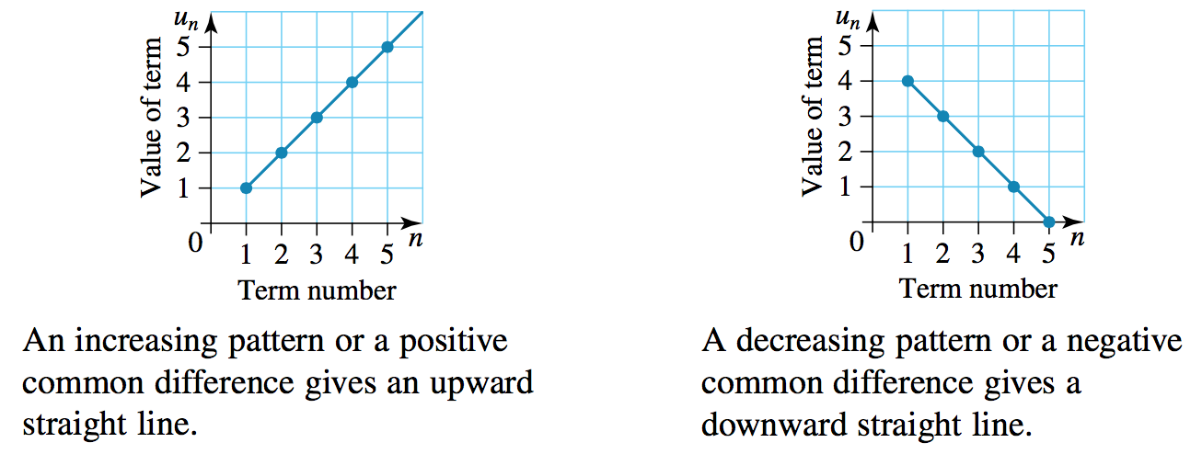

## Worked Example 8

On a graph, show the first five terms of the sequence described by the first-order recurrence relation:

un+1 = un – 3 u1 = -5

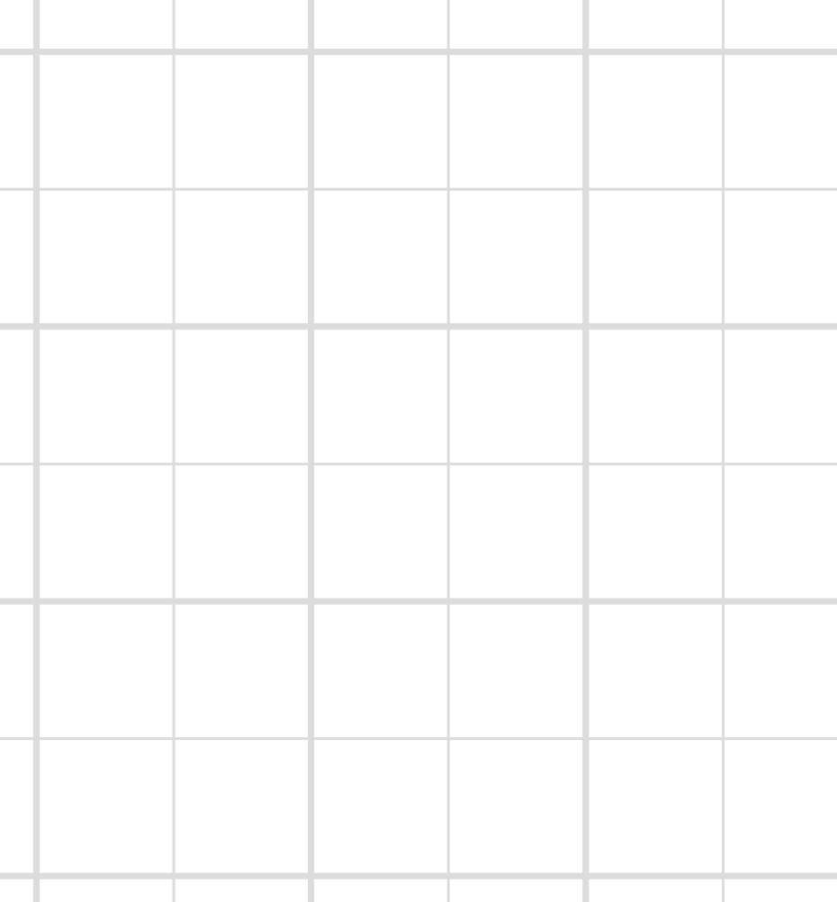

## Worked Example 8: Using the CAS calculator

|  |  |  |
| --- | --- | --- |
| Enter the first term   * Enter -5 v5 * Press ·   Enter the equation   * Enter “Ans-3” or /v-3 |  | 1st term  enter equation |
| Press · for the 2nd term  Press · for the 3rd term  Press · for the 4th term  Press · for the 5th term |  | 1st term  2nd term  3rd term  4th term  5th term |

# First-order recurrence relations: un+1 = Run

The sequence of a first-order recurrence relation un+1 = Run are distinguished by a curved line or a fluctuating (saw) form.

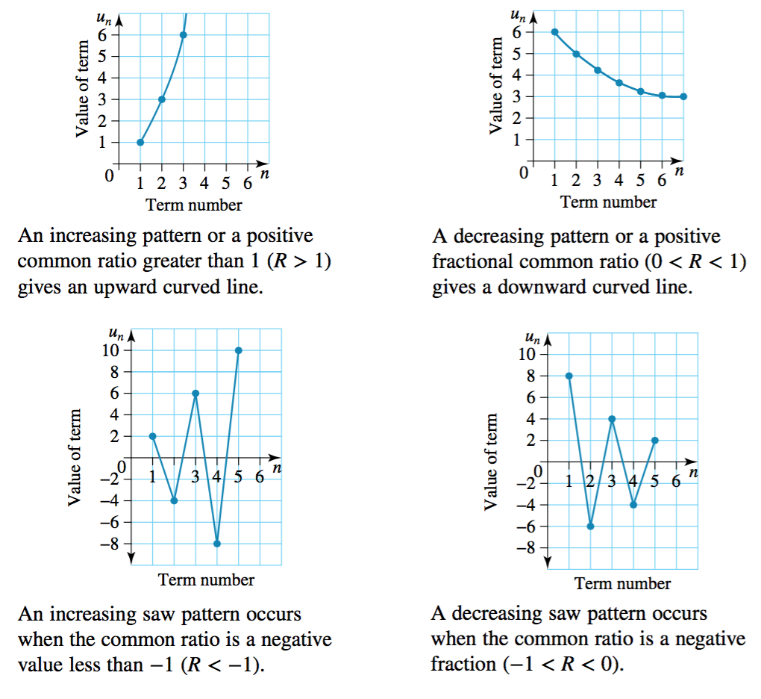

## Worked example 9

On a graph, show the first five terms of the sequence described by the first-order recurrence relation:

un+1 = 4un u1 = 0.5



## Worked example 9: Using CAS calculator

You can choose to determine the terms on the CAS and plot the graph by hand. Like this…

|  |  |
| --- | --- |
| Enter the starting term:  On a calculator page   * Enter the number 0^5· * Enter /vr4·for the 2nd term * Press ·for the 3rd term * Press ·for the 4th term * Press ·for the 5th term |  |
| **OR** you could do it all on the CAS. Like this… |  |
| * Label column A “n” * Enter the n values in column A * Label column B “values” * Enter the first term 0.5 in the first cell of column B * In the next cell (B2) enter the equation after an = |  |
| Now fill down this equation to the cells below.  Press   * Menu b * data 3 * fill 3 |  |
| Add a data and statistics page /~  Put the “n” on the x axis and “values” on the y axis |  |

# Interpretation of the graph of first-order recurrence relations

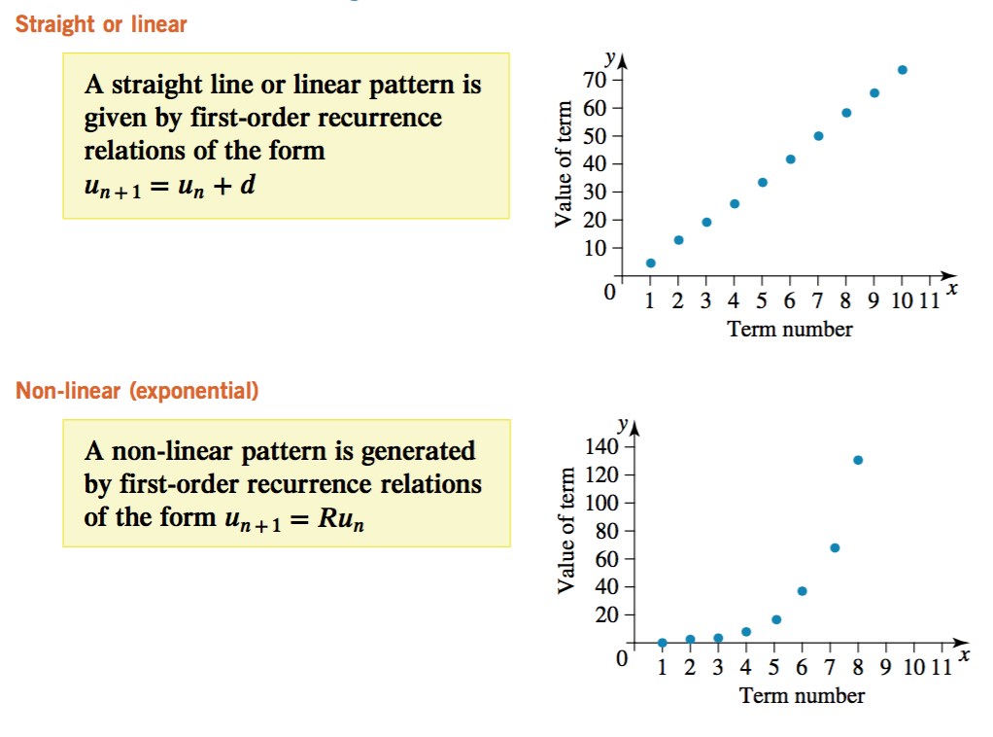

## Worked Example 10

The first five terms of a sequence are plotted on the graph, Write the first-order recurrence relation that defines this sequence.

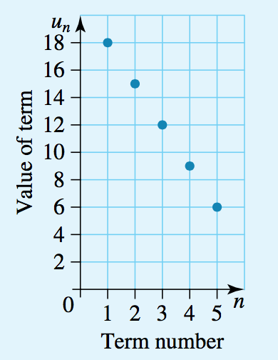

## Worked Example 11

The first four terms of a sequence are plotted on the graph. Write the first-order recurrence relation that defines this sequence

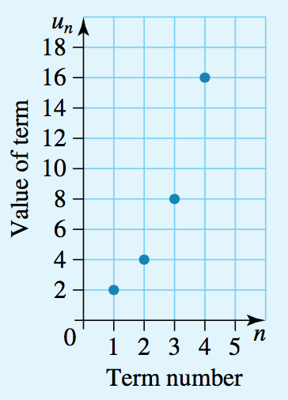

## Worked Example 12

The first five terms of a sequence are plotted on the graph shown. Which of the following first-order recurrence relations could describe the sequence?



**Graph Grids for chapter 5.4**

|  |  |  |
| --- | --- | --- |
| Q | Q | Q |
| Q | Q | Q |
| Q | Q | Q |
| Q | Q | Q |

**Graph Grids for chapter 5.4**

|  |  |  |
| --- | --- | --- |
| Q | Q | Q |
| Q | Q | Q |
| Q | Q | Q |
| Q | Q | Q |

Student’s Chapter 5 Summary Page

…………………………………………………………………………………………………………………………………………………………....….

…………………………………………………………………………………………………………………………………………………………....….

…………………………………………………………………………………………………………………………………………………………....….

…………………………………………………………………………………………………………………………………………………………....….

…………………………………………………………………………………………………………………………………………………………....….

…………………………………………………………………………………………………………………………………………………………....….

…………………………………………………………………………………………………………………………………………………………....….

…………………………………………………………………………………………………………………………………………………………....….

…………………………………………………………………………………………………………………………………………………………....….

…………………………………………………………………………………………………………………………………………………………....….

…………………………………………………………………………………………………………………………………………………………....….

…………………………………………………………………………………………………………………………………………………………....….

…………………………………………………………………………………………………………………………………………………………....….

…………………………………………………………………………………………………………………………………………………………....….

…………………………………………………………………………………………………………………………………………………………....….

…………………………………………………………………………………………………………………………………………………………....….

…………………………………………………………………………………………………………………………………………………………....….

…………………………………………………………………………………………………………………………………………………………....….

…………………………………………………………………………………………………………………………………………………………....….

…………………………………………………………………………………………………………………………………………………………....….

…………………………………………………………………………………………………………………………………………………………....….

…………………………………………………………………………………………………………………………………………………………....….

…………………………………………………………………………………………………………………………………………………………....….

…………………………………………………………………………………………………………………………………………………………....….

…………………………………………………………………………………………………………………………………………………………....….

…………………………………………………………………………………………………………………………………………………………....….

…………………………………………………………………………………………………………………………………………………………....….

…………………………………………………………………………………………………………………………………………………………....….

…………………………………………………………………………………………………………………………………………………………....….

…………………………………………………………………………………………………………………………………………………………....….

…………………………………………………………………………………………………………………………………………………………....….

1. *Each time we apply the rule it is called an iteration.