**Review — Topic 5: Graphs and networks**

**Multiple choice**

1. The minimum number of edges in a connected graph with eight vertices is:

**A** 5

**B** 6

**C** 7

**D** 8

**E** 9

1. Which graph is a spanning tree for the following graph?

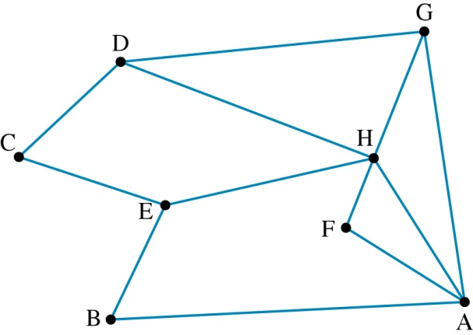

|  |  |
| --- | --- |
| **A** | D:\Documents\Writing and editing\Wiley\Maths Quest 11 GM\eBook\3_Art\FINAL\Chapters\JPG\R5.02.jpg |
| **B** | D:\Documents\Writing and editing\Wiley\Maths Quest 11 GM\eBook\3_Art\FINAL\Chapters\JPG\R5.03.jpg |
| **C** | D:\Documents\Writing and editing\Wiley\Maths Quest 11 GM\eBook\3_Art\FINAL\Chapters\JPG\R5.04.jpg |
| **D** | D:\Documents\Writing and editing\Wiley\Maths Quest 11 GM\eBook\3_Art\FINAL\Chapters\JPG\R5.05.jpg |
| **E** | D:\Documents\Writing and editing\Wiley\Maths Quest 11 GM\eBook\3_Art\FINAL\Chapters\JPG\R5.06.jpg |

1. A connected graph with 9 vertices has 10 faces. The number of edges in the graph is:

**A** 15

**B** 16

**C** 17

**D** 18

**E** 19

1. Which of the following graphs will not have an Euler trail?

|  |  |
| --- | --- |
| **A** | D:\Documents\Writing and editing\Wiley\Maths Quest 11 GM\eBook\3_Art\FINAL\Chapters\JPG\R5.07.jpg |
| **B** | D:\Documents\Writing and editing\Wiley\Maths Quest 11 GM\eBook\3_Art\FINAL\Chapters\JPG\R5.08.jpg |
| **C** | D:\Documents\Writing and editing\Wiley\Maths Quest 11 GM\eBook\3_Art\FINAL\Chapters\JPG\R5.09.jpg |
| **D** | D:\Documents\Writing and editing\Wiley\Maths Quest 11 GM\eBook\3_Art\FINAL\Chapters\JPG\R5.10.jpg |
| **E** | D:\Documents\Writing and editing\Wiley\Maths Quest 11 GM\eBook\3_Art\FINAL\Chapters\JPG\R5.11.jpg |
|  |  |

1. What is the length of the minimum spanning tree of the following graph?

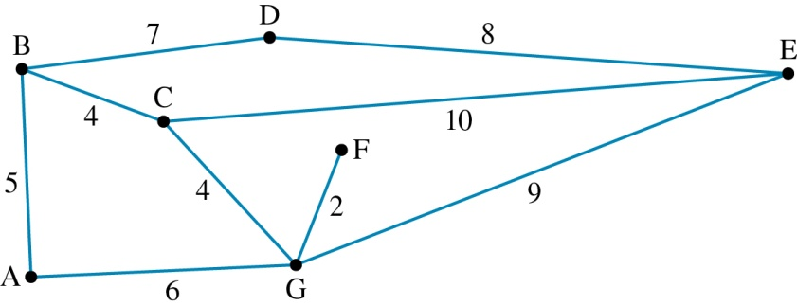

**A** 33

**B** 26

**C** 34

**D** 31

**E** 30

1. An Euler circuit can be created in the following graph by adding an edge between the vertices:

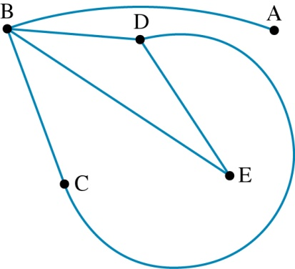

**A** A and D

**B** A and B

**C** A and C

**D** B and C

**E** A and E

1. The adjacency matrix that represents the following graph is:

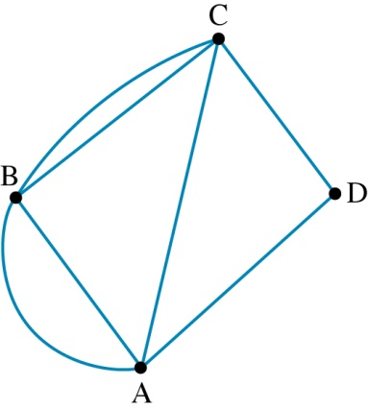

**A** 

**B** 

**C** 

**D** 

**E** 

1. The number of faces in the following planar graph is:

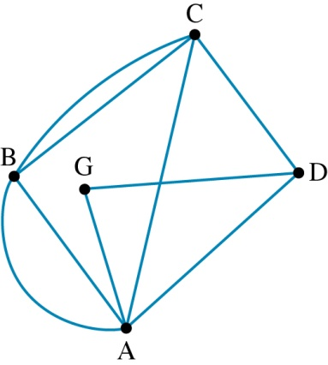

**A** 6

**B** 7

**C** 8

**D** 9

**E** 10

1. A Hamiltonian cycle for the following graph is:

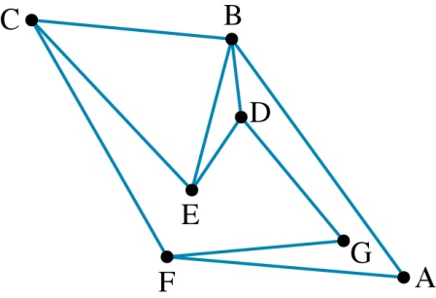

**A** ABCEDGFA

**B** ABDGFCEA

**C** ABDGFCEDEBCFA

**D** ABDGFCECFA

**E** ABDGFA

1. A complete graph with 7 vertices will have a total number of edges of:

**A** 7

**B** 8

**C** 14

**D** 42

**E** 21

**Short answer**

1. **a** Identify whether the following graphs are planar or not planar.

|  |  |
| --- | --- |
| **i** | D:\Documents\Writing and editing\Wiley\Maths Quest 11 GM\eBook\3_Art\FINAL\Chapters\JPG\R5.17.jpg |
| **ii** | D:\Documents\Writing and editing\Wiley\Maths Quest 11 GM\eBook\3_Art\FINAL\Chapters\JPG\R5.18.jpg |
| **iii** | D:\Documents\Writing and editing\Wiley\Maths Quest 11 GM\eBook\3_Art\FINAL\Chapters\JPG\R5.19.jpg |
| **iv** | D:\Documents\Writing and editing\Wiley\Maths Quest 11 GM\eBook\3_Art\FINAL\Chapters\JPG\R5.20.jpg |

**b** Redraw the graphs that are planar without any intersecting edges.

1. Complete the following adjacency matrices.

**a** 

**b** 

**c** 

**d** 

1. Identify which of the following graphs are:

**i** simple **ii** complete **iii** planar.

|  |  |  |  |
| --- | --- | --- | --- |
| **a** | D:\Documents\Writing and editing\Wiley\Maths Quest 11 GM\eBook\3_Art\FINAL\Chapters\JPG\R5.21.jpg | **e** | D:\Documents\Writing and editing\Wiley\Maths Quest 11 GM\eBook\3_Art\FINAL\Chapters\JPG\R5.25.jpg |
| **b** | D:\Documents\Writing and editing\Wiley\Maths Quest 11 GM\eBook\3_Art\FINAL\Chapters\JPG\R5.22.jpg | **f** | D:\Documents\Writing and editing\Wiley\Maths Quest 11 GM\eBook\3_Art\FINAL\Chapters\JPG\R5.26.jpg |
| **c** | D:\Documents\Writing and editing\Wiley\Maths Quest 11 GM\eBook\3_Art\FINAL\Chapters\JPG\R5.23.jpg | **g** | D:\Documents\Writing and editing\Wiley\Maths Quest 11 GM\eBook\3_Art\FINAL\Chapters\JPG\R5.27.jpg |
| **d** | D:\Documents\Writing and editing\Wiley\Maths Quest 11 GM\eBook\3_Art\FINAL\Chapters\JPG\R5.24.jpg | **h** | D:\Documents\Writing and editing\Wiley\Maths Quest 11 GM\eBook\3_Art\FINAL\Chapters\JPG\R5.28.jpg |
|  |  |  |  |

1. Which of the following graphs are isomorphic?

|  |  |
| --- | --- |
| **a** | D:\Documents\Writing and editing\Wiley\Maths Quest 11 GM\eBook\3_Art\FINAL\Chapters\JPG\R5.29.jpg |
| **b** | D:\Documents\Writing and editing\Wiley\Maths Quest 11 GM\eBook\3_Art\FINAL\Chapters\JPG\R5.30.jpg |
| **c** | D:\Documents\Writing and editing\Wiley\Maths Quest 11 GM\eBook\3_Art\FINAL\Chapters\JPG\R5.31.jpg |
| **d** | D:\Documents\Writing and editing\Wiley\Maths Quest 11 GM\eBook\3_Art\FINAL\Chapters\JPG\R5.32.jpg |

1. For each of the following graphs:

**i** add the minimum number of edges to the following graphs in order to create an Euler trail

**ii** state the Euler trail created.

**a**

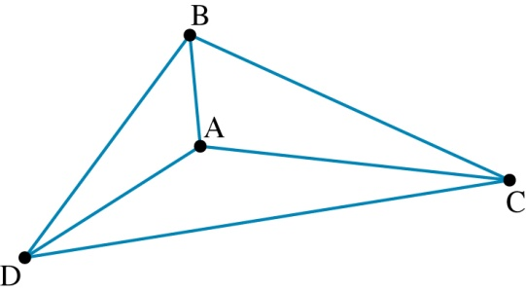

**b**

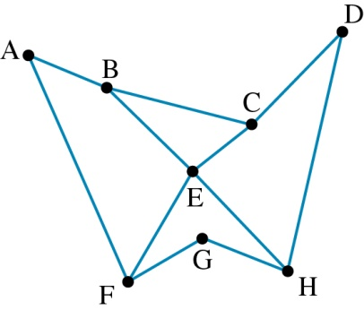

1. **a** What is the shortest distance from start to finish in the following graph?

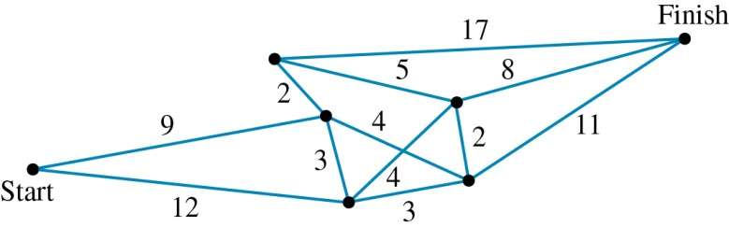

**b** What is the total length of the shortest Hamiltonian path from start to finish?

**c** Draw the minimum spanning tree for this graph.

**Extended response**

1. The flying distances between the capital cities of Australian mainland states and territories are listed in the following table.

|  |  |  |  |  |  |  |  |
| --- | --- | --- | --- | --- | --- | --- | --- |
|  | **Adelaide** | **Brisbane** | **Canberra** | **Darwin** | **Melbourne** | **Perth** | **Sydney** |
| **Adelaide** |  | 2055 | 1198 | 3051 | 732 | 2716 | 1415 |
| **Brisbane** | 2055 |  | 1246 | 3429 | 1671 | 4289 | 982 |
| **Canberra** | 1198 | 1246 |  | 4003 | 658 | 3741 | 309 |
| **Darwin** | 3051 | 3429 | 4003 |  | 3789 | 4049 | 4301 |
| **Melbourne** | 732 | 1671 | 658 | 3789 |  | 3456 | 873 |
| **Perth** | 2716 | 4363 | 3741 | 4049 | 3456 |  | 3972 |
| **Sydney** | 1415 | 982 | 309 | 4301 | 873 | 3972 |  |

**a** Draw a weighted graph to show this information.

**b** If technical problems are preventing direct flights from Melbourne to Darwin and from Melbourne to Adelaide, what is the shortest way of flying from Melbourne to Darwin?

**c** If no direct flights are available from Brisbane to Perth or from Brisbane to Adelaide, what is the shortest way of getting from Brisbane to Perth?

**d** Draw the minimum spanning tree for the graph and state its total distance.

1. The diagram shows the streets in a suburb of a city with a section of underground tunnels shown in black. Weightings indicate distances in metres. The tunnels are used for utilities such as electricity, gas, water and drainage.

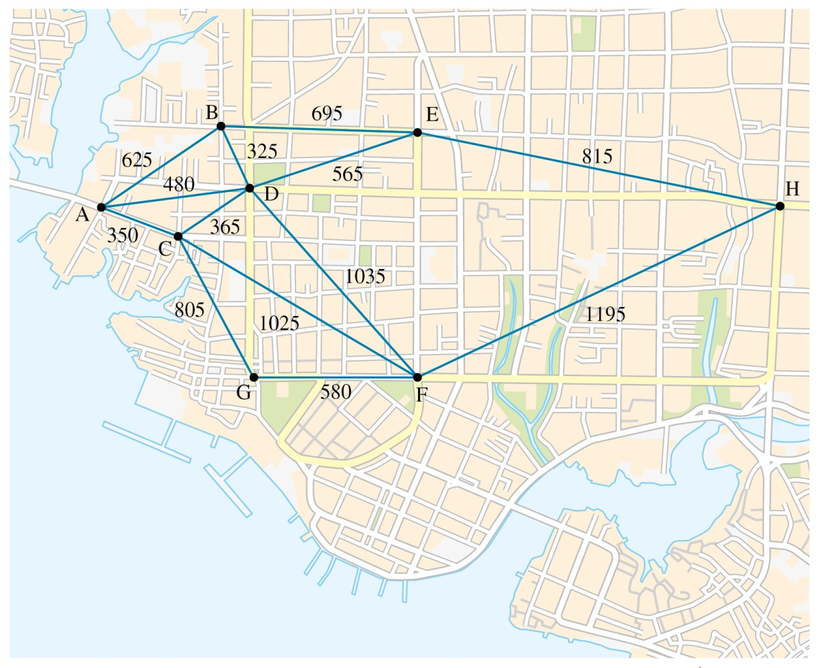

**a i** If the gas company wishes to run a pipeline that minimises its total length but reaches each vertex, what will be the total length required?

**ii** Draw a graph to show the gas lines.

**b** If drainage pipes need to run from H to A, what is the shortest path they can follow? How long will this path be in total?

**c** A single line of cable for a computerised monitoring system needs to be placed so that it starts at D and reaches every vertex once. What is the minimum length possible, and what is the path it must follow?

**d** If a power line has to run from D so that it reaches every vertex at least once and finishes back at the start, what path must it take to be a minimum?

1. A brochure for a national park includes a map showing the walking trails and available camping sites at the park.

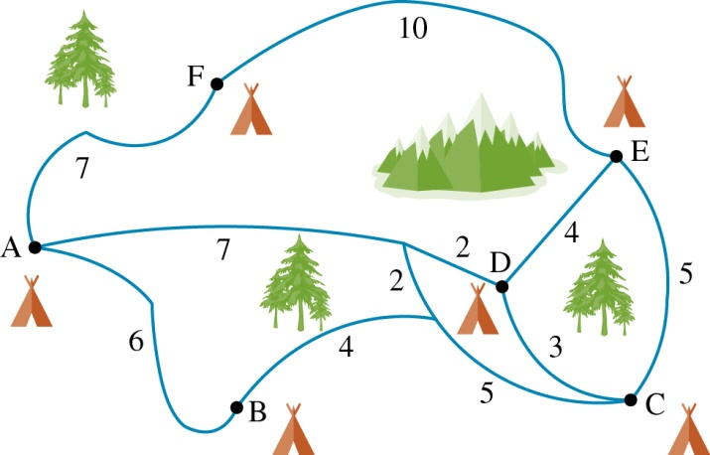

**a** Draw a weighted graph to represent all the possible ways of travelling to the camp sites.

**b** Draw the adjacency matrix for the graph.

**c** Is it possible to walk a route that travels along each edge exactly once? Explain your answer, and indicate the path if it is possible.

**d** If the main entrance to the park is situated at A, what is the shortest way to travel to each campsite and return to A?

1. A cruise ship takes passengers around Tasmania between the seven locations marked on the map.

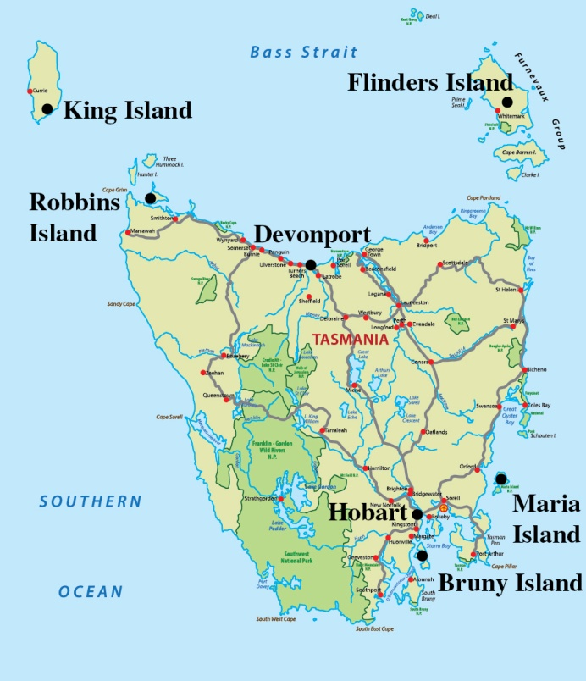

The sailing distances between locations are indicated in the table.

|  |  |  |  |  |  |  |  |
| --- | --- | --- | --- | --- | --- | --- | --- |
|  | **Hobart** | **Bruny I.** | **Maria I.** | **Flinders I.** | **Devonport** | **Robbins I.** | **King I.** |
| **Hobart** | – | 65 km | 145 km | 595 km | 625 km | – | – |
| **Bruny I.** | 65 km | – | 130 km | – | – | 715 km | – |
| **Maria I.** | 145 km | 130 km | – | 450 km | – | – | – |
| **Flinders I.** | 595 km | – | 450 km | – | 330 km | 405 km | 465 km |
| **Devonport** | 625 km | – | – | 330 km | – | 265 km | 395 km |
| **Robbins I.** | – | 715 km | – | 405 km | 265 km | – | 120 km |
| **King I.** | – | – | – | 465 km | 395 km | 120 km | – |

**a** Draw a weighted graph to represent all possible ways of travelling to the locations.

**b** What is the shortest route from Hobart to Robbins Island?

**c** What is the shortest way of travelling from Hobart to visit each location only once?

**d** What is the shortest way of sailing from King Island, visiting each location once and returning to King Island?

**Review — answers**

**Multiple choice**

**1** C **2** B **3** C **4** D **5** E

**6** A **7** E **8** A **9** A **10** E

**Short answer**

**1 a i** Planar **ii**  Planar **iii** Planar **iv** Planar

**b i**

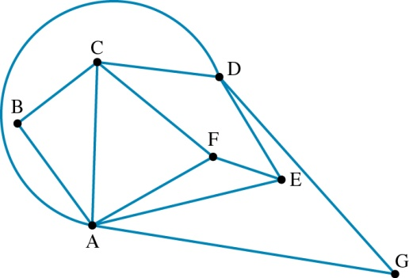

**ii**

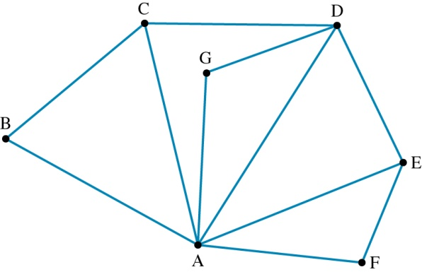

**iii**

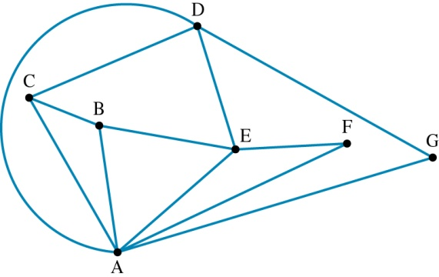

**iv**

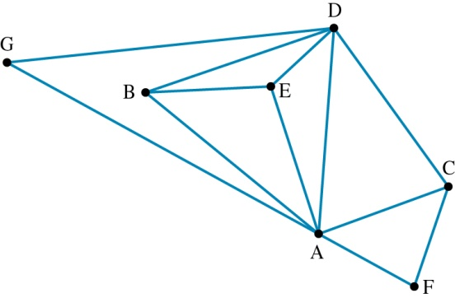

**2 a **

**b**  ****

**c **

**d **

**3 a** Simple, planar

**b**  Simple, planar

**c**  Simple, complete, planar

**d**  Simple, planar

**e**  Simple, complete

**f**  Simple, planar

**g**  Simple, planar

**h**  Simple, planar

**4** Graphs **a** and **d** are isomorphic.

**5 a i** 3

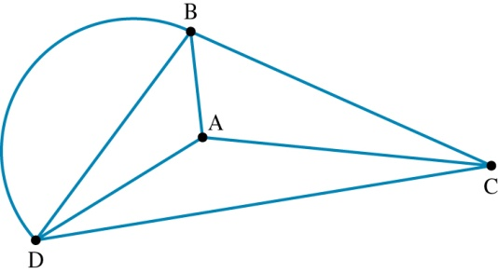

**ii** ABDBCADC

**b i**

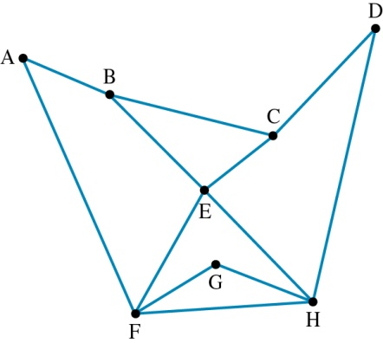

**ii** BAFEHGFHDCEBC

**6 a** 9 + 4 + 2 + 8 = 23

**b** 9 + 2 + 2 + 5 + 4 + 3 + 11 = 34

**c**

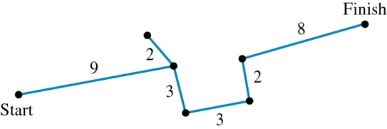

**Extended response**

**1 a**

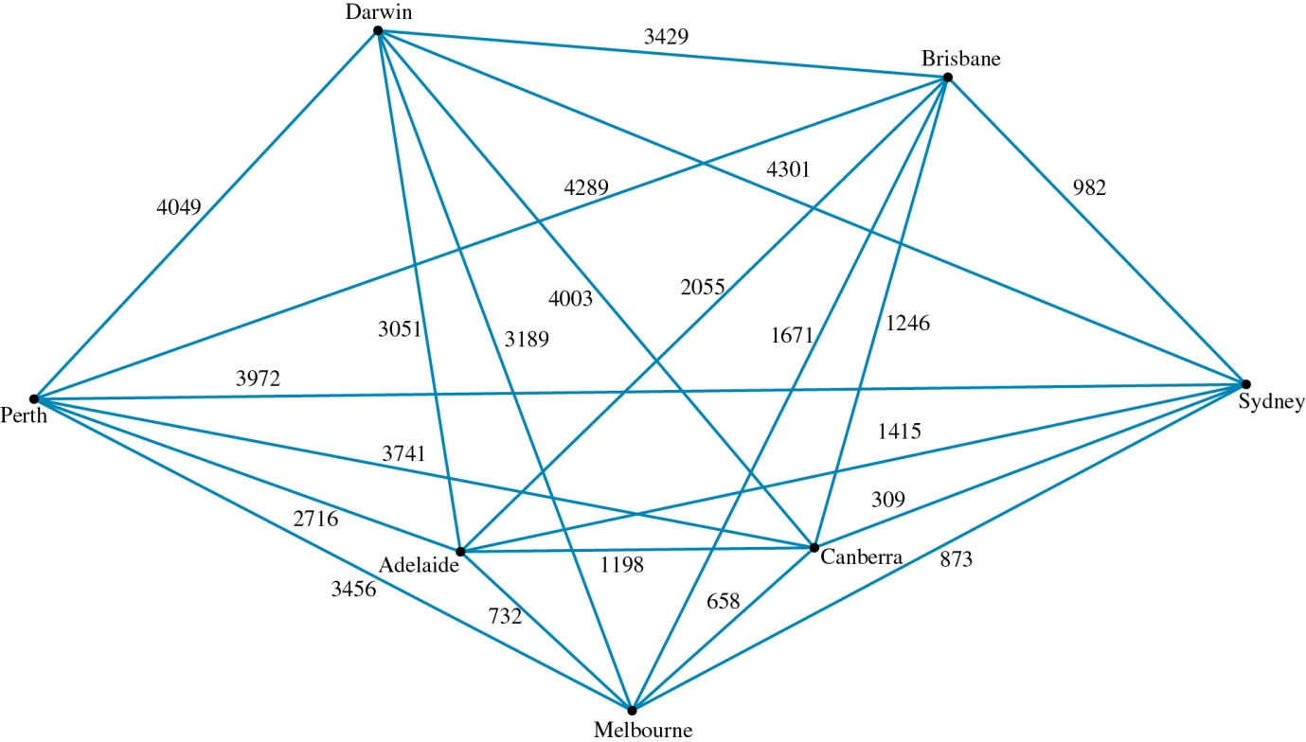

**b** Via Canberra (4661 km)

**c** Via Sydney (4954 km)

**d**

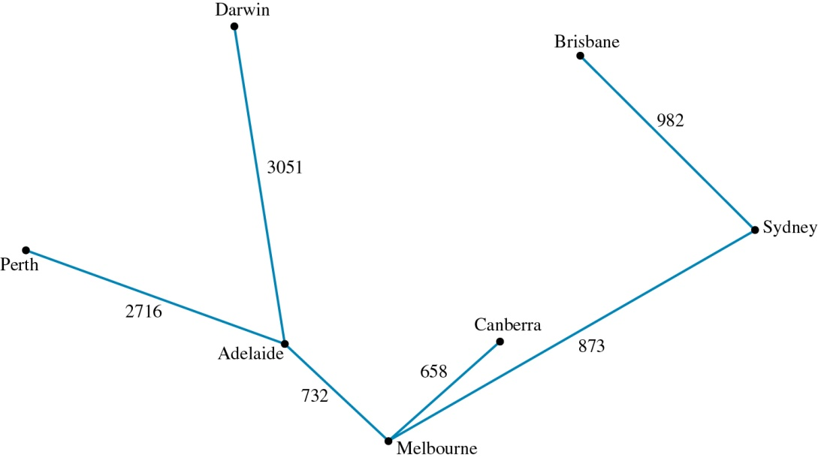

The total distance is 9012 km.

**2 a** **i** 4195 m

**ii**

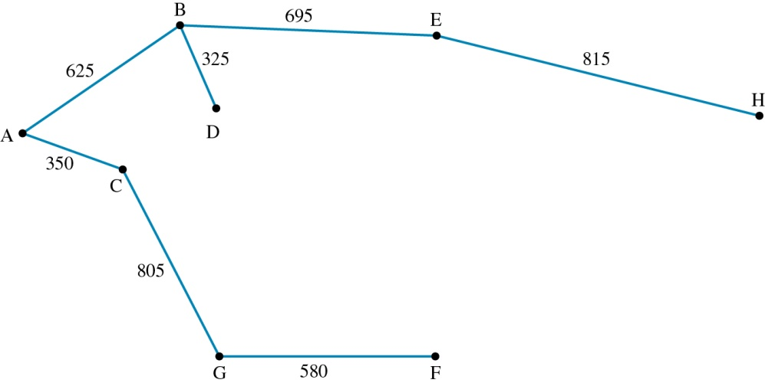

**b** HEDA, 1860 m

**c** 4905 m, DFGCABEH

**d** DEHFGCABD, 5260 m

**3 a**

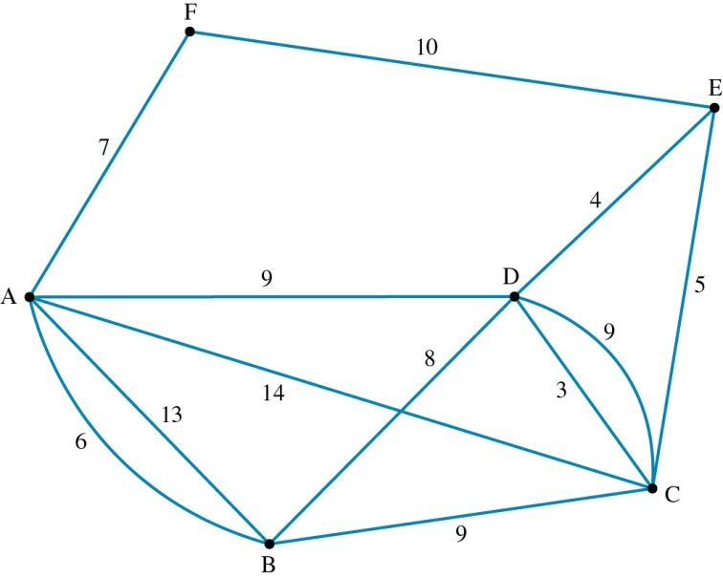

**b** 

**c** No, as there are more than two vertices of odd degree.

**d** AFEDCBA (39)

**4 a**

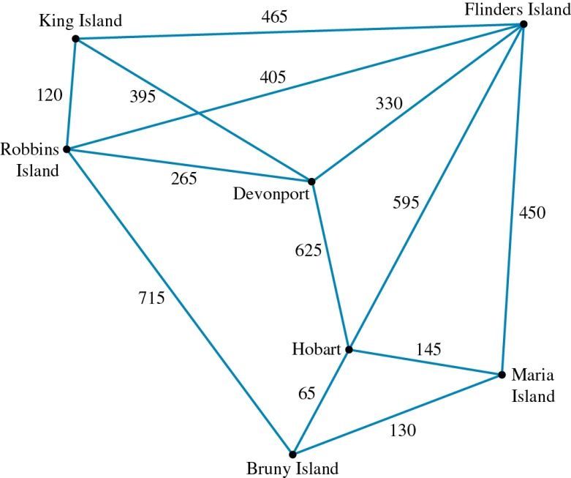

**b** Hobart–Bruny–Robbins (780 km)

**c** Hobart–Bruny–Robbins–King–Devonport–Flinders–Maria (2075 km)

**d** King–Devonport–Flinders–Maria–Hobart–Bruny–Robbins–King (2220 km)